OPTIMIZE EMR
Product Walkthrough
The EMR purpose-built for men's and women's optimization clinics
Hormone optimization · Sexual wellness · Peptide therapy
A guided tour of the complete system: front desk, clinical visits, lab review, patient messaging, the patient portal, and business analytics, shown exactly as your team and your patients would use it.

See it with your own workflows
To arrange access to the demo system, or to talk through your clinic's EMR needs, contact sales@codeforgedsystems.com.
Customizations are available. Tell us how your clinic runs and we will show you how Optimize EMR fits it.

Code Forged Systems · All screens in this document show fictional demonstration data. No real patient information appears anywhere.

Why optimization clinics choose Optimize EMR
General-purpose EMRs are built for primary care and hospitals. An optimization clinic runs differently: recurring weekly visits, in-clinic injections, home regimens, monthly labs judged against optimal targets, memberships instead of insurance claims. Optimize EMR is designed around that model from the first screen.
- Purpose-built for male and female optimization. Testosterone replacement, menopausal and perimenopausal hormone therapy, sexual wellness and peptide protocols are first-class workflows. A clinic can serve men, women, or both, and every screen adapts.
- Designed for high efficiency. A weekly treatment visit moves through check-in, rooming, vitals, clinical review, medication and checkout in a handful of clicks. Each role sees one prioritized list of what needs action now.
- Highly tuned, specialized workflows. Dosing protocols, injection-site rotation, syringe draw volumes, lab cadence, and normal-plus-optimal lab ranges are built in. Nothing has to be forced into a generic template.
- Reduced error. A five-rights medication check, a visual syringe guide, lot and expiry capture, allergy banners on every chart, and automatic lab flags put the safety checks in front of staff at the moment they matter.
- Improved communications. One shared clinic inbox ties every patient request to the chart, assigns an owner and a due time, and keeps secure replies in one thread. Automated reminders help keep patients on schedule.
- Faster, more efficient scheduling. Provider, room and clinic-hours conflicts are checked before a booking is saved. Recurring cadences, next-visit suggestions at checkout, and patient self-scheduling keep the calendar full without phone tag.
- Patient portal access. Patients see released labs with plain-language explanations, their treatment plan, upcoming visits, and a secure line to the clinic, on a phone or a computer.
- Business analytics for growth. Visit volume, staffing coverage, room load, patient demand, therapy mix and membership revenue are reported across every location so owners can put resources where they earn the most.

Ready for a closer look?
Email sales@codeforgedsystems.com to arrange demo access or to discuss your EMR needs. Customizations are available.

One system for men's, women's, and combined clinics
Each location is set up as a men's clinic, a women's clinic, or both. That single setting tunes the charts, treatment catalog, lab ranges and visit steps your staff see, so nobody works around screens that do not apply to their patients.
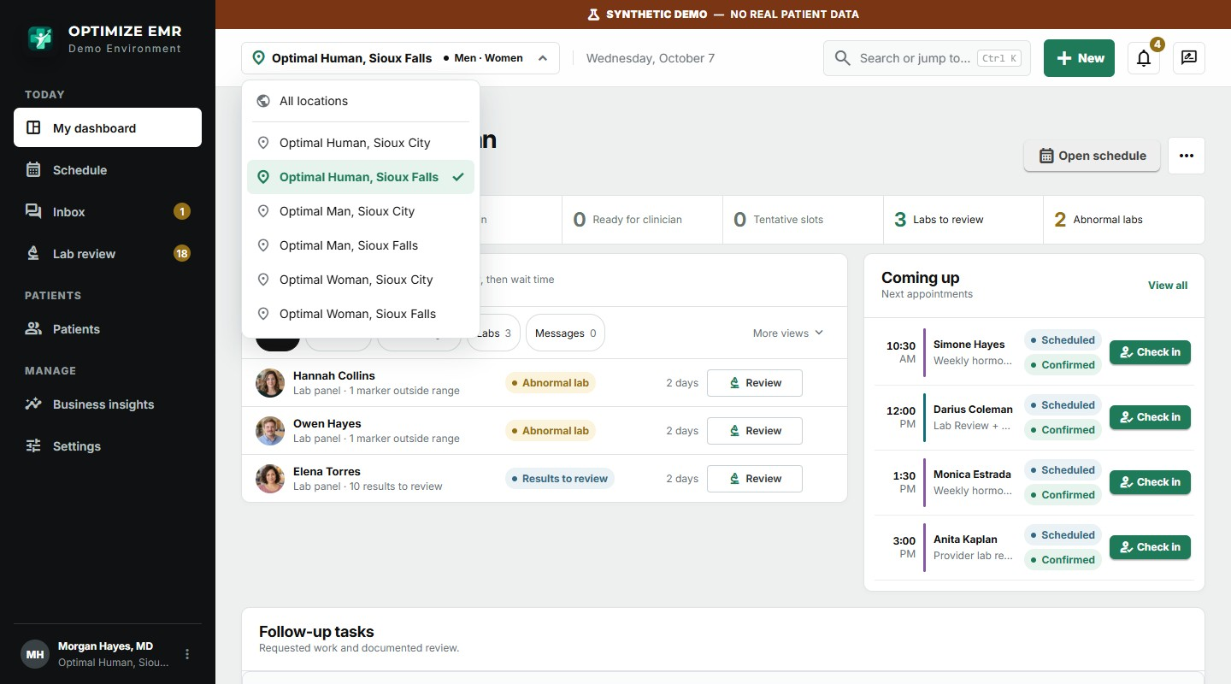
Multi-location owners move between clinics, or view all locations at once, from the clinic switcher.

A men's chart and a women's chart, side by side in the same clinic
In a combined clinic the same provider can open a man on weekly testosterone and a woman on menopausal hormone therapy back to back. Each chart shows the context that matters for that patient: TRT dosing protocol and weekly targets for him; menopause stage, cycle and reproductive history, and home regimens for her.
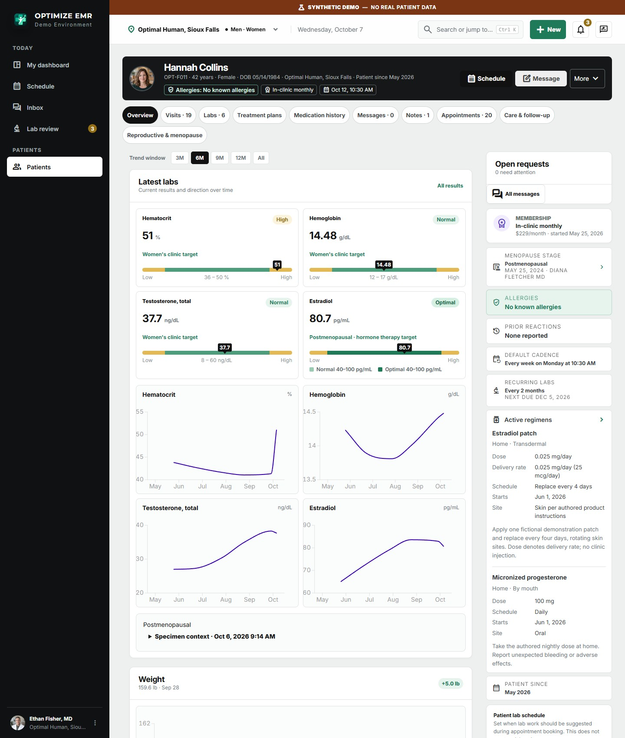
Women's chart in a combined clinic: labs judged against women's ranges, with her regimens, membership and cadence alongside.
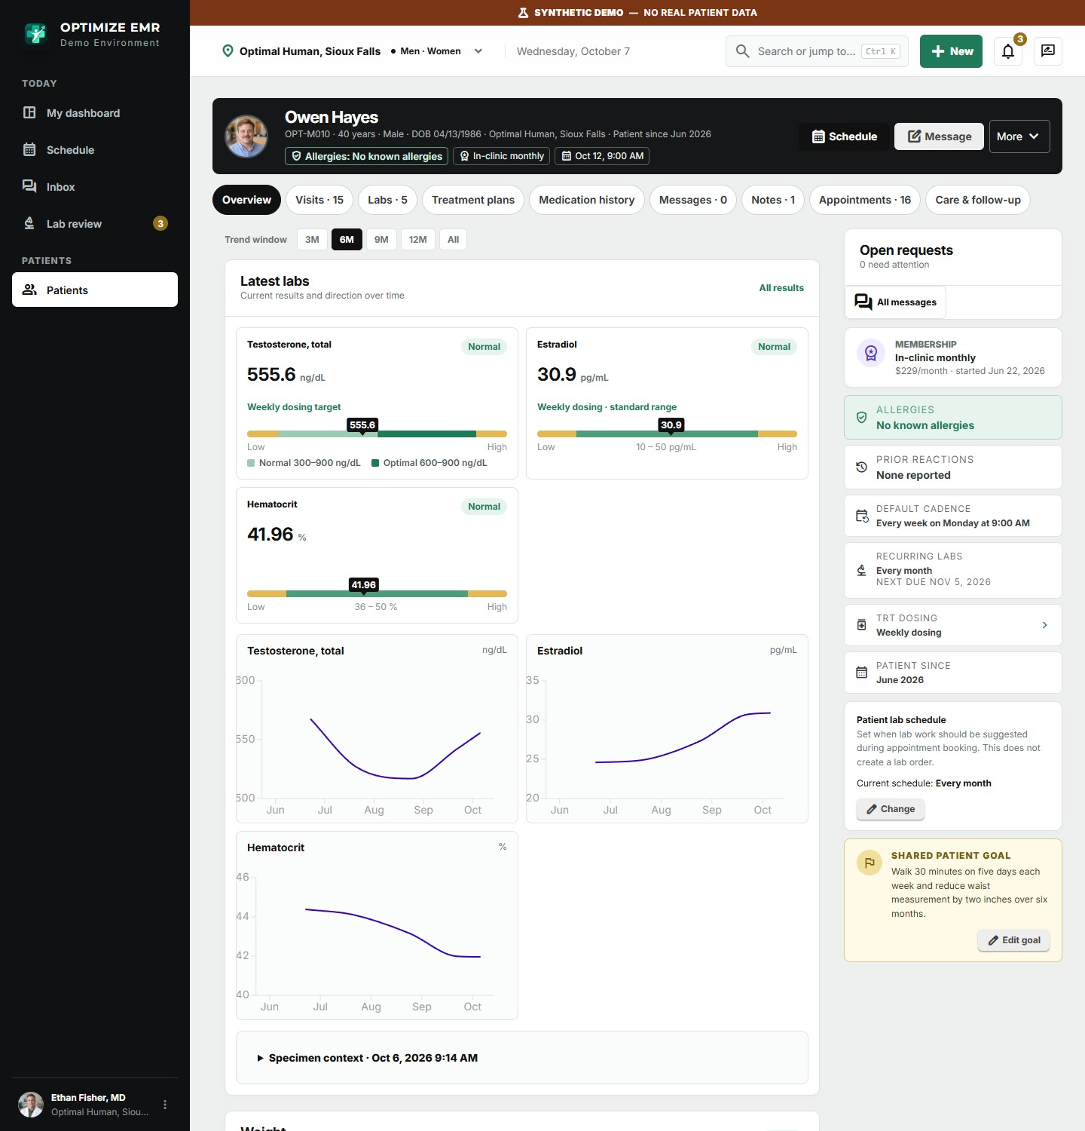
Men's chart in the same clinic: testosterone shown against the normal and optimal bands, with dosing protocol and visit cadence alongside.

Front desk: a full calendar without the phone tag
Front-desk staff start the day on a dashboard that lists exactly what needs action, then work from a schedule that already knows each clinic's hours, rooms and providers.
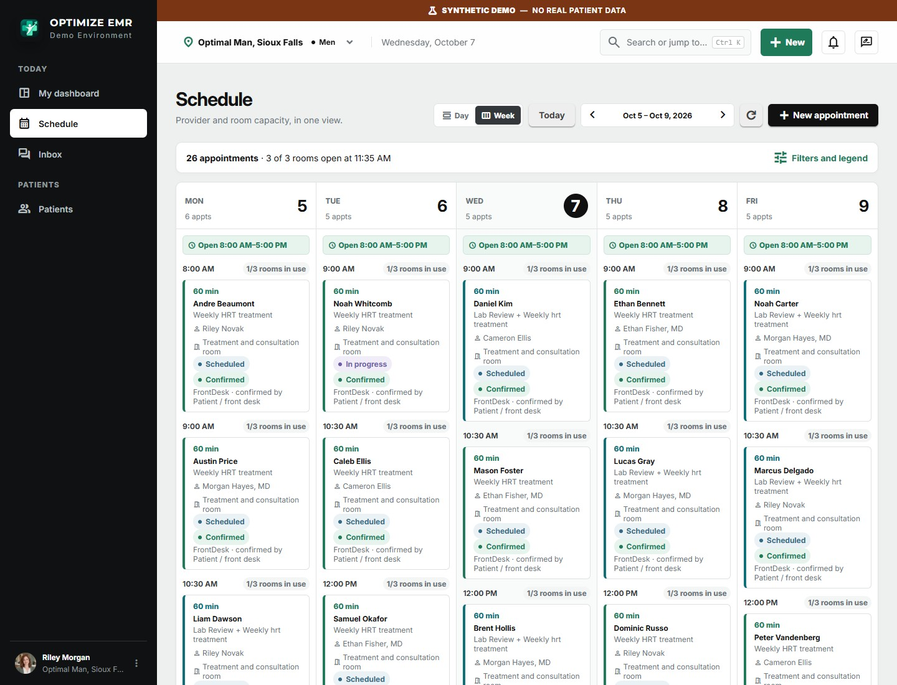
Week view. Every appointment shows its type, provider, room, status and how it was confirmed.

Check in from the schedule
Selecting an appointment opens a side panel with one-click check-in, the patient's chart, and rescheduling. The clinical team sees the arrival on their dashboard immediately.
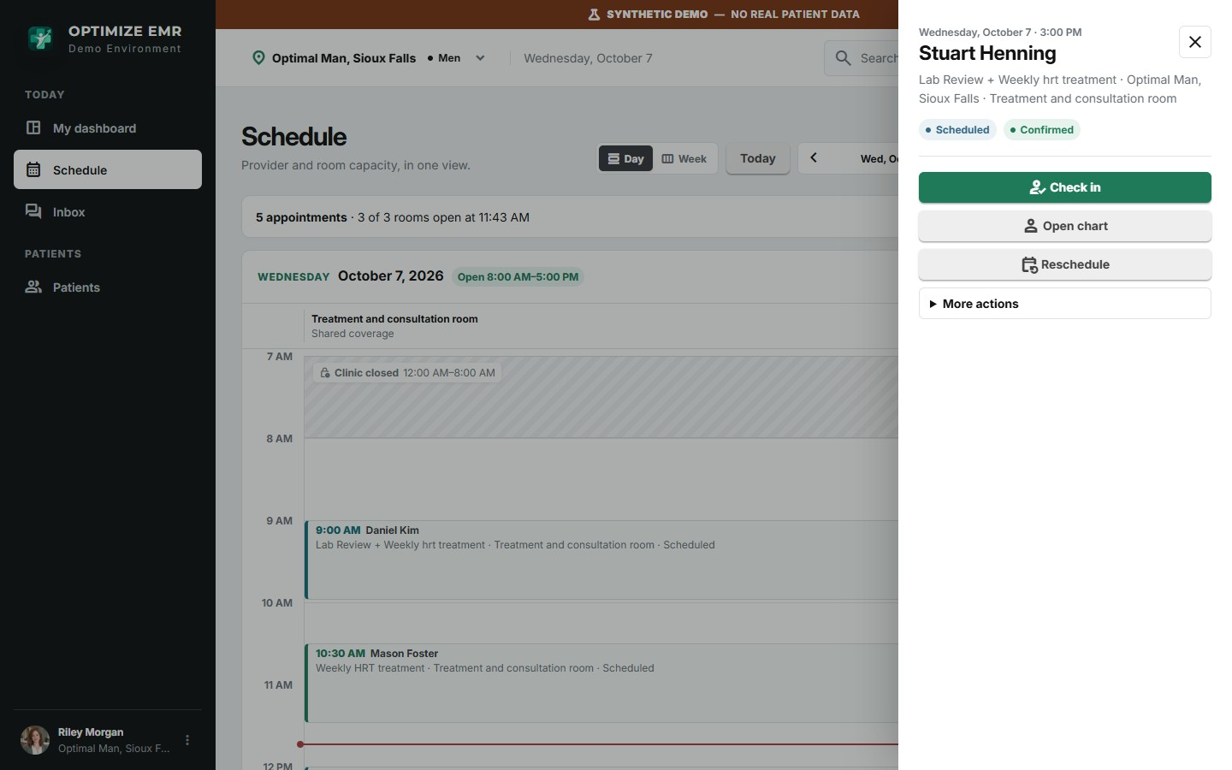
Appointment panel opened from the day schedule.

Booking that prevents conflicts
When a visit is booked, clinic capacity, clinician coverage, office hours, closures, provider and room conflicts are checked before the appointment is saved. Appointment types carry their own duration and workflow steps, so a lab draw, a lab review and a weekly treatment each reserve the right resources. Patients can also request or book eligible times from the portal.
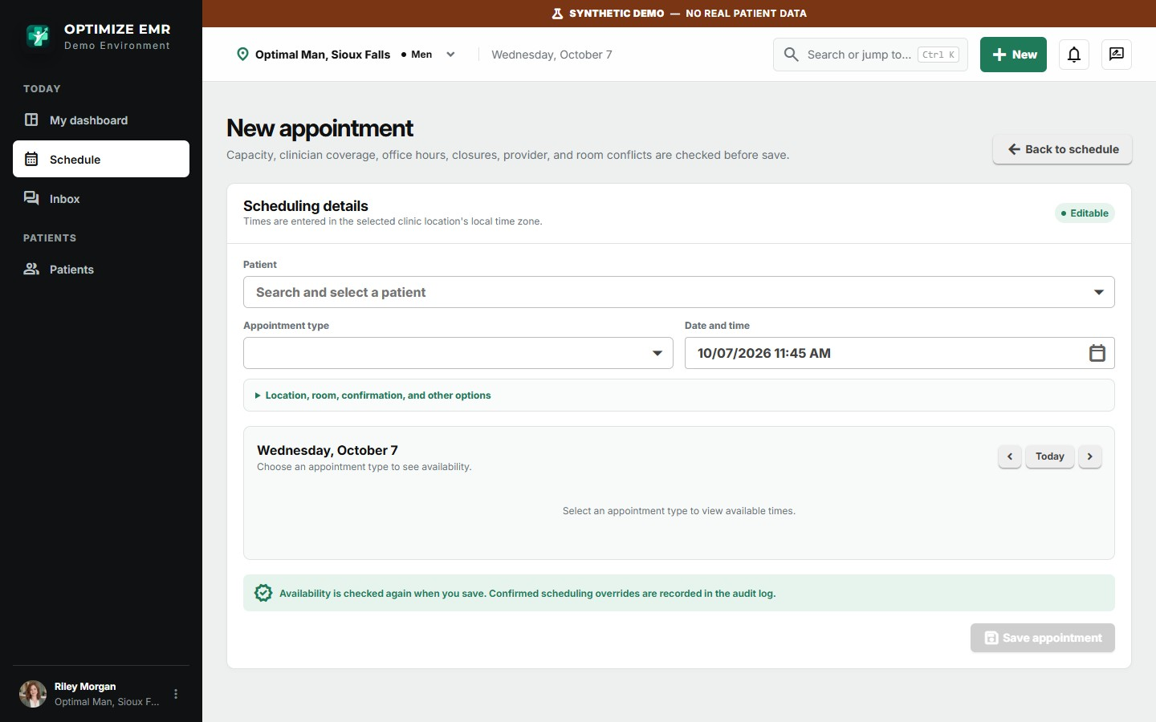
New appointment: open times appear for the chosen appointment type and day.
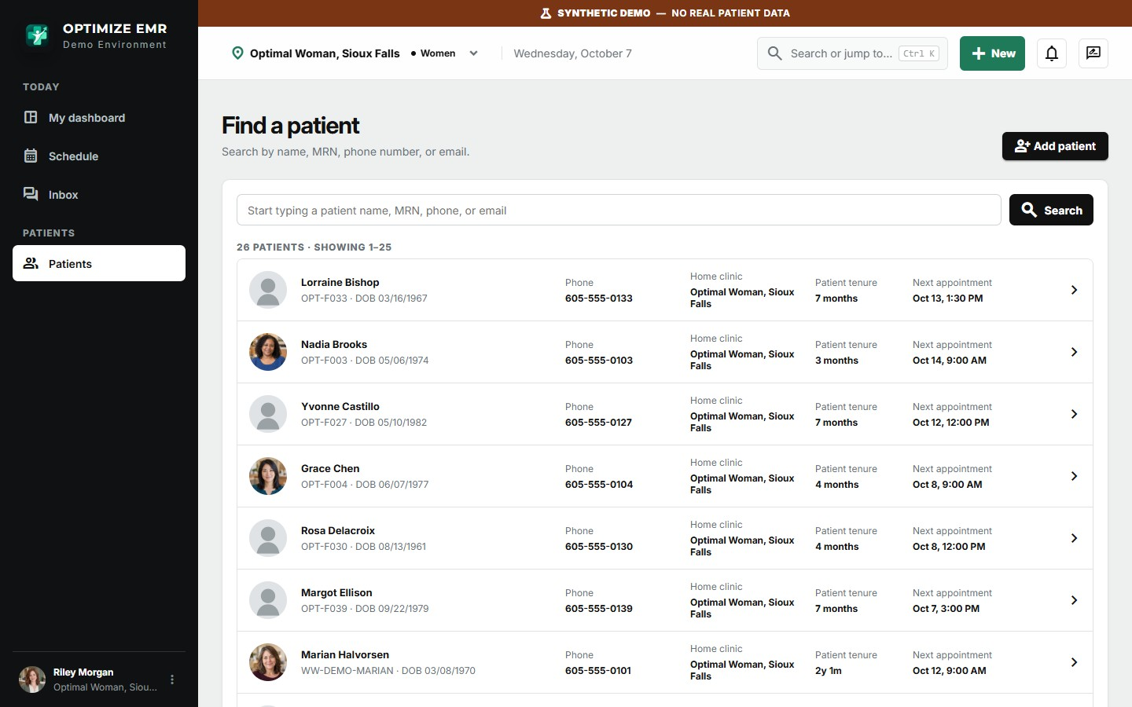
Patient search by name, record number, phone or email, with tenure and next appointment at a glance.

The clinical visit: guided, fast, and hard to get wrong
A weekly treatment visit is the heartbeat of an optimization clinic. Optimize EMR turns it into a guided sequence, so a visit that takes minutes in the room takes seconds to document.
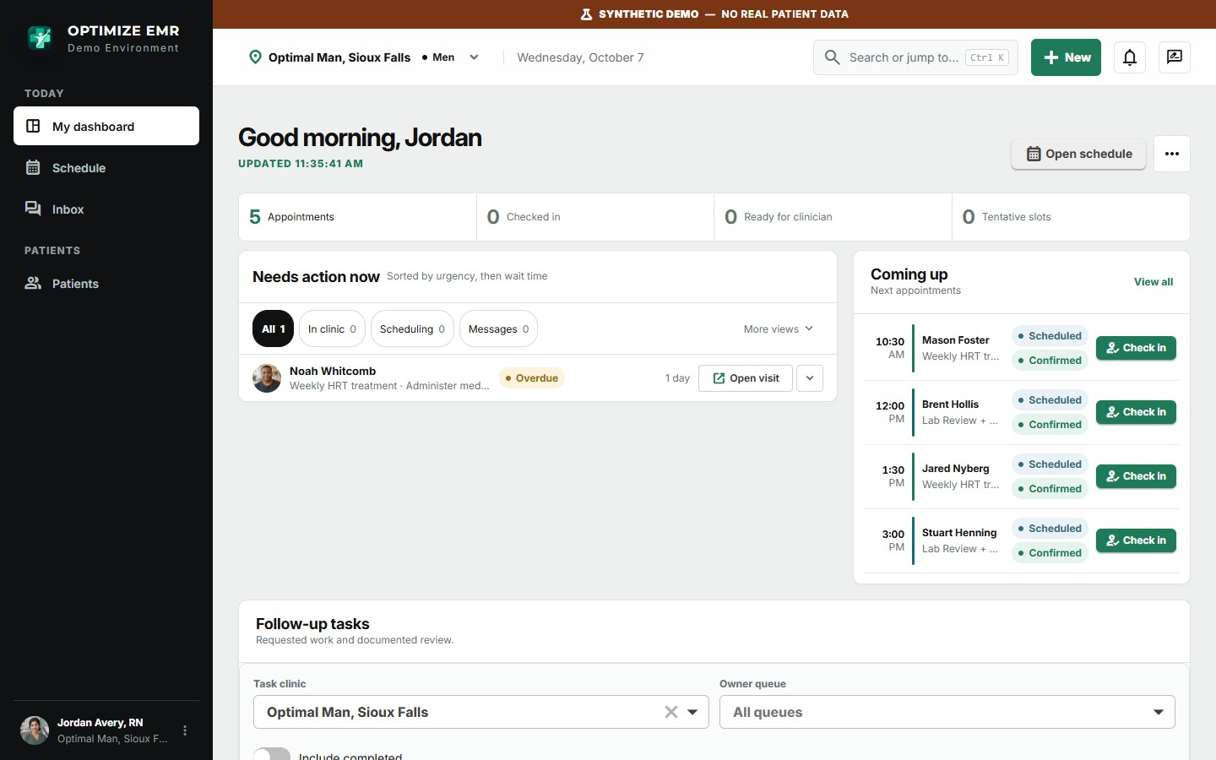
The clinical team's dashboard: the checked-in patient is at the top with the next step named.

Step-by-step visit workspace
The progress bar across the top shows where the visit stands: check-in, room, vitals, clinical review, provider (only when one is needed), medication, and post-visit. Steps that do not apply to the visit type are skipped automatically. A woman on a home regimen never sees an injection step.
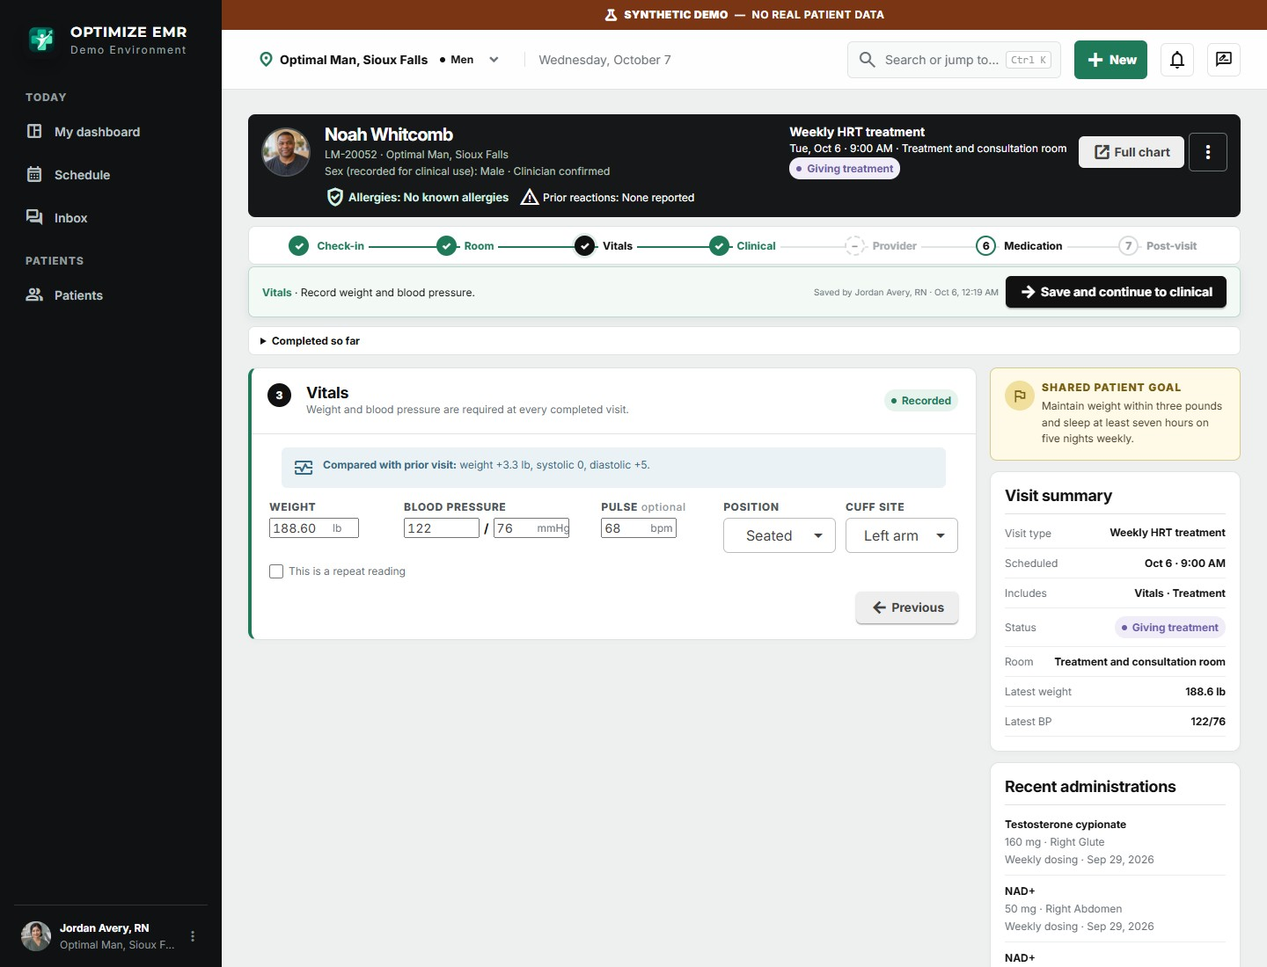
Vitals are compared with the prior visit as they are entered.
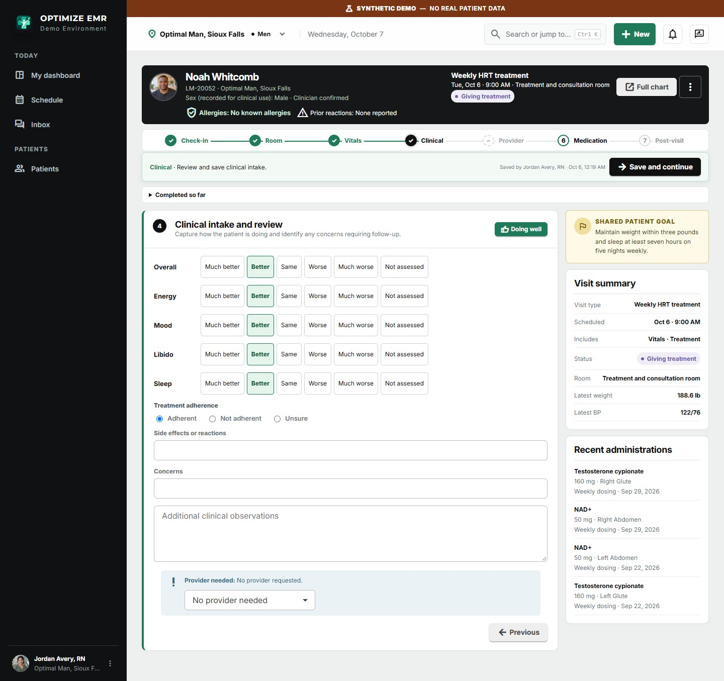
Clinical review: one tap on “Doing well” records all five symptom trends; adherence, side effects and concerns sit on the same screen.

Medication administration with a five-rights check
This is where specialized design reduces error. The exact medication, concentration, prescribed dose and draw volume come straight from the provider-authored treatment plan. The syringe graphic shows how far to draw for the selected syringe size, the body diagram shows the planned site with left and right rotation applied, and the five rights (patient, medication, dose, route, time) are confirmed on screen. Lot number and expiration are captured with the outcome.
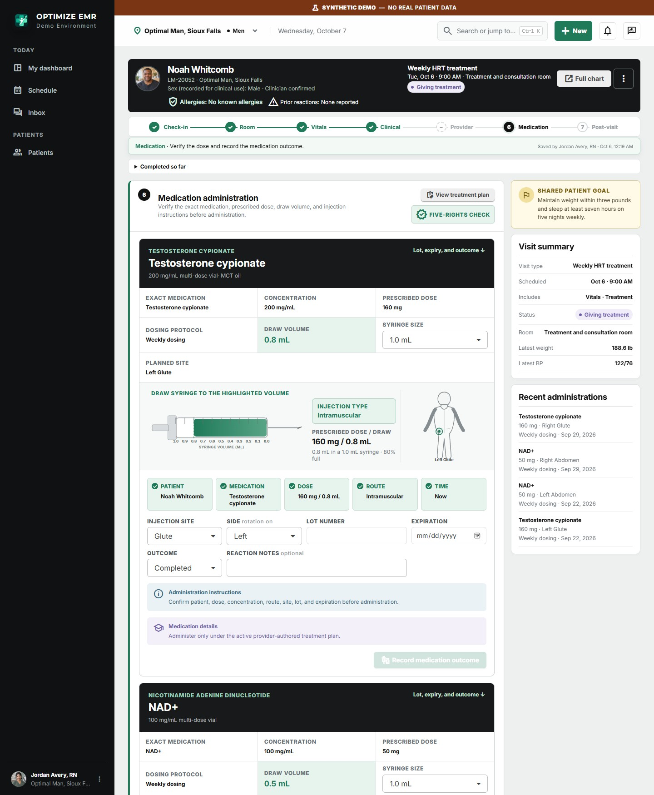
Medication administration: dose, draw volume, syringe guide, injection site and the five-rights check for each medication due at the visit.

Women's visits follow the same rhythm
For women the visit carries menopause and wellness check-ins and reviews adherence to home regimens such as patches, oral progesterone or topical therapy, using the same quick symptom pickers.
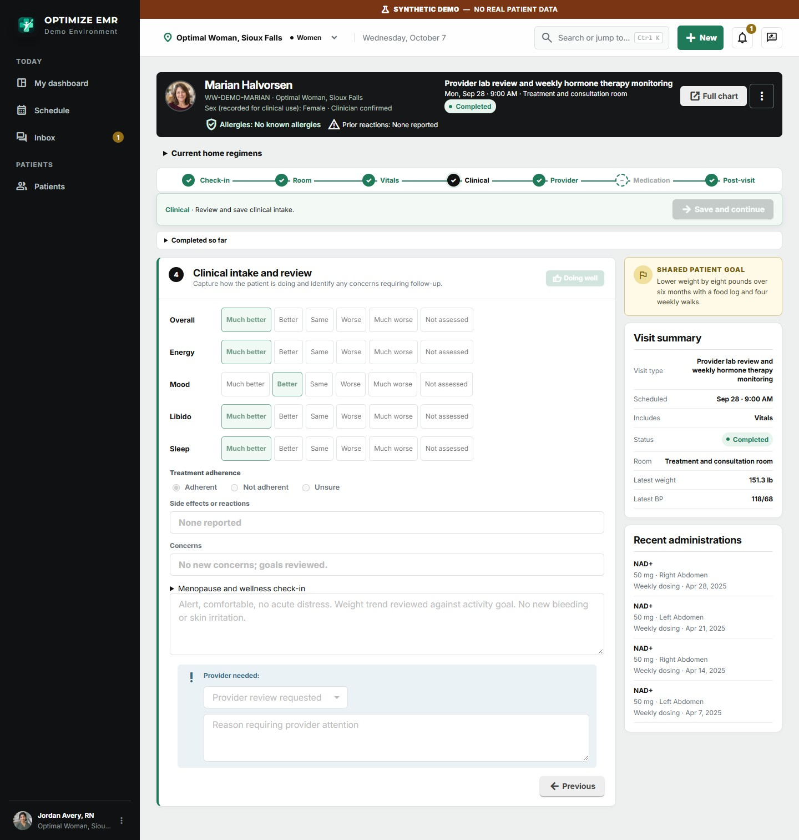
A women's hormone therapy monitoring visit. The medication step is skipped because therapy is taken at home.

Lab review built for optimization, not just “in range”
Optimization medicine cares about where a result sits inside the range. Every marker is drawn on a banded bar showing the clinic's normal range and, where you define one, its optimal range.
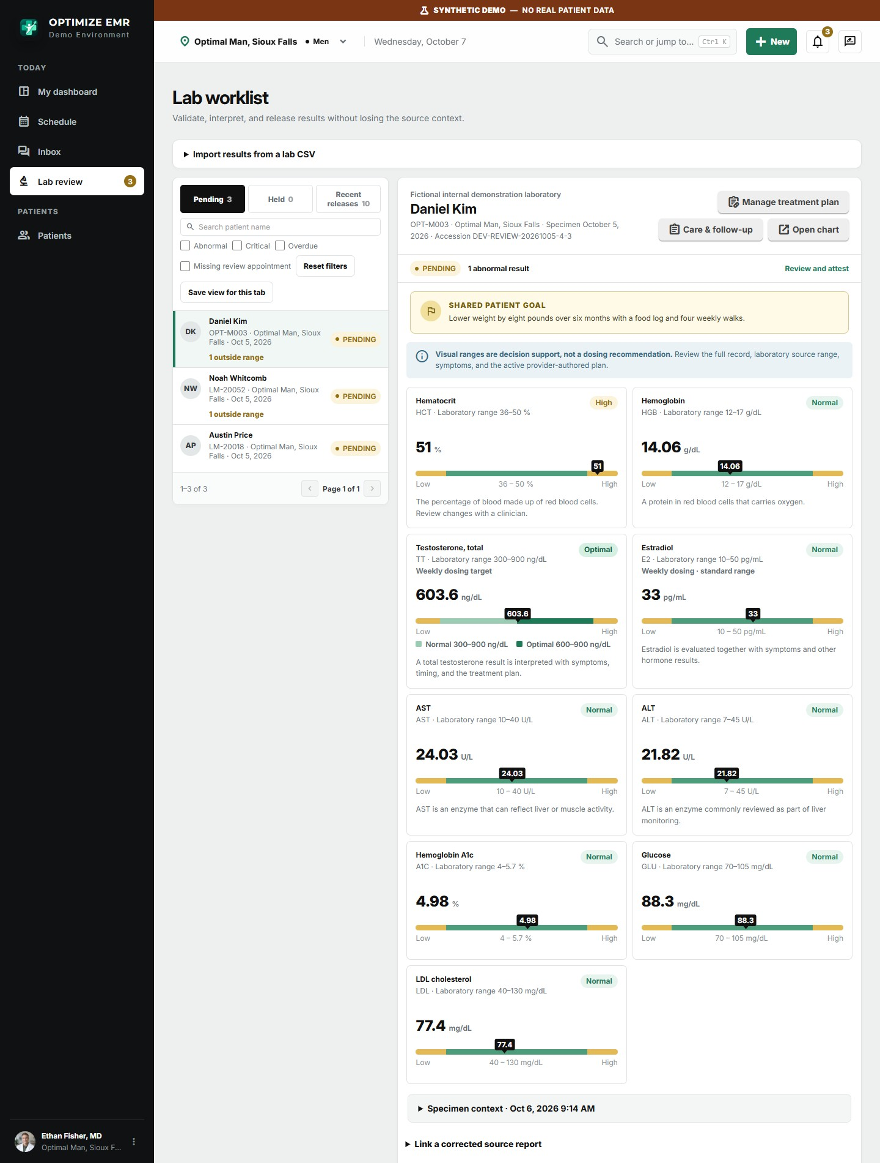
Provider lab worklist. Pending panels on the left; every result is flagged and placed on its range bar, with the patient's shared goal in view.
- Clinic-defined targets. Set normal and optimal ranges per marker, per dosing protocol for men and per stage, cycle phase or therapy for women. For example, a weekly-dosing testosterone target for men, an estradiol target for women on menopausal hormone therapy, and a separate total testosterone target shown only to women on testosterone therapy. Ranges are effective-dated and carry medical-director approval.
- Import and attest. Results are imported from a lab file, reviewed, attested by the provider, and released to the patient portal in one flow. Abnormal and critical results rise to the top of the worklist and create follow-up work.
- Trends over time. Each chart plots testosterone, estradiol, hematocrit and other key markers across 3, 6, 9 or 12 months, or the full history.
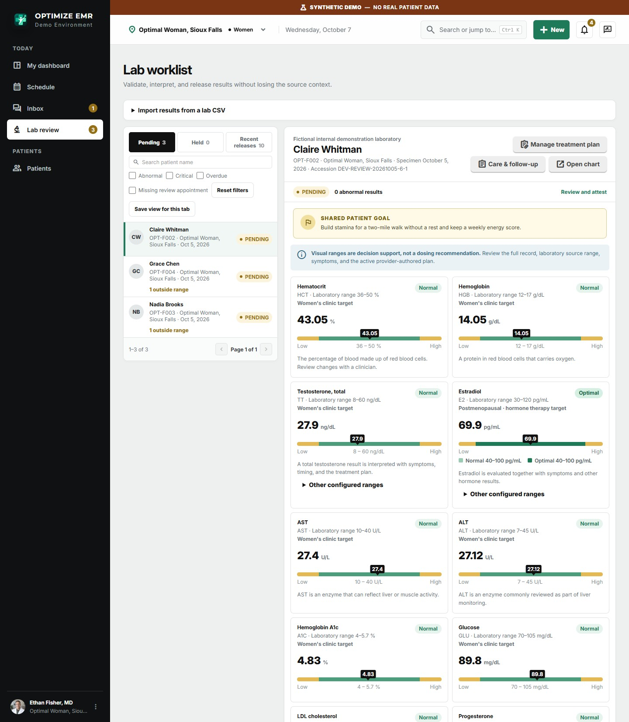
The same worklist in a women's clinic, with results read against women's clinic targets.
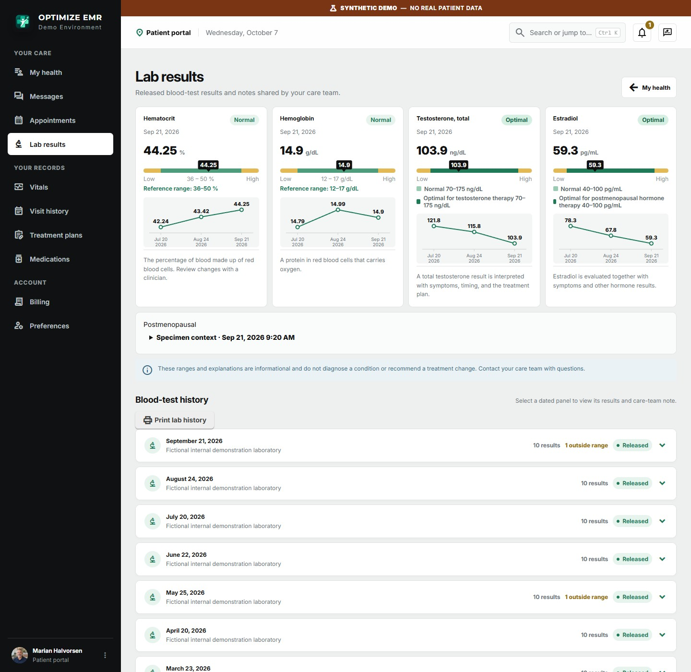
A woman on hormone therapy sees her estradiol and testosterone against the optimal range for her therapy.

The patient chart: the whole story on one page
Allergies, the next appointment, dosing protocol, visit cadence, lab cadence, the latest results with trends, weight and blood pressure, membership, and the goal the patient agreed with their provider are all visible without leaving the overview.
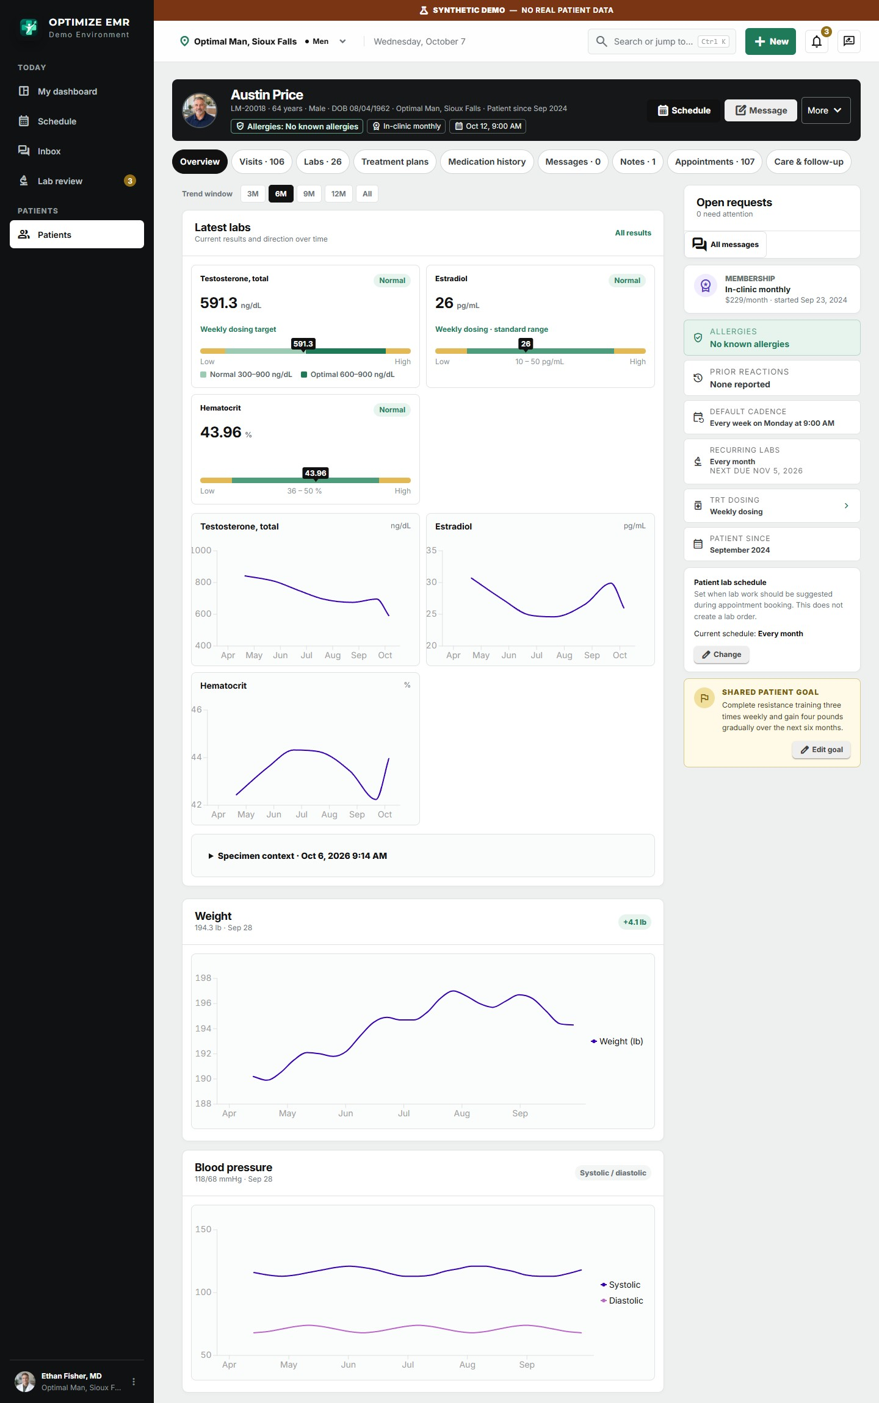
Men's chart overview. Total testosterone is shown as Optimal against the clinic's weekly-dosing target.
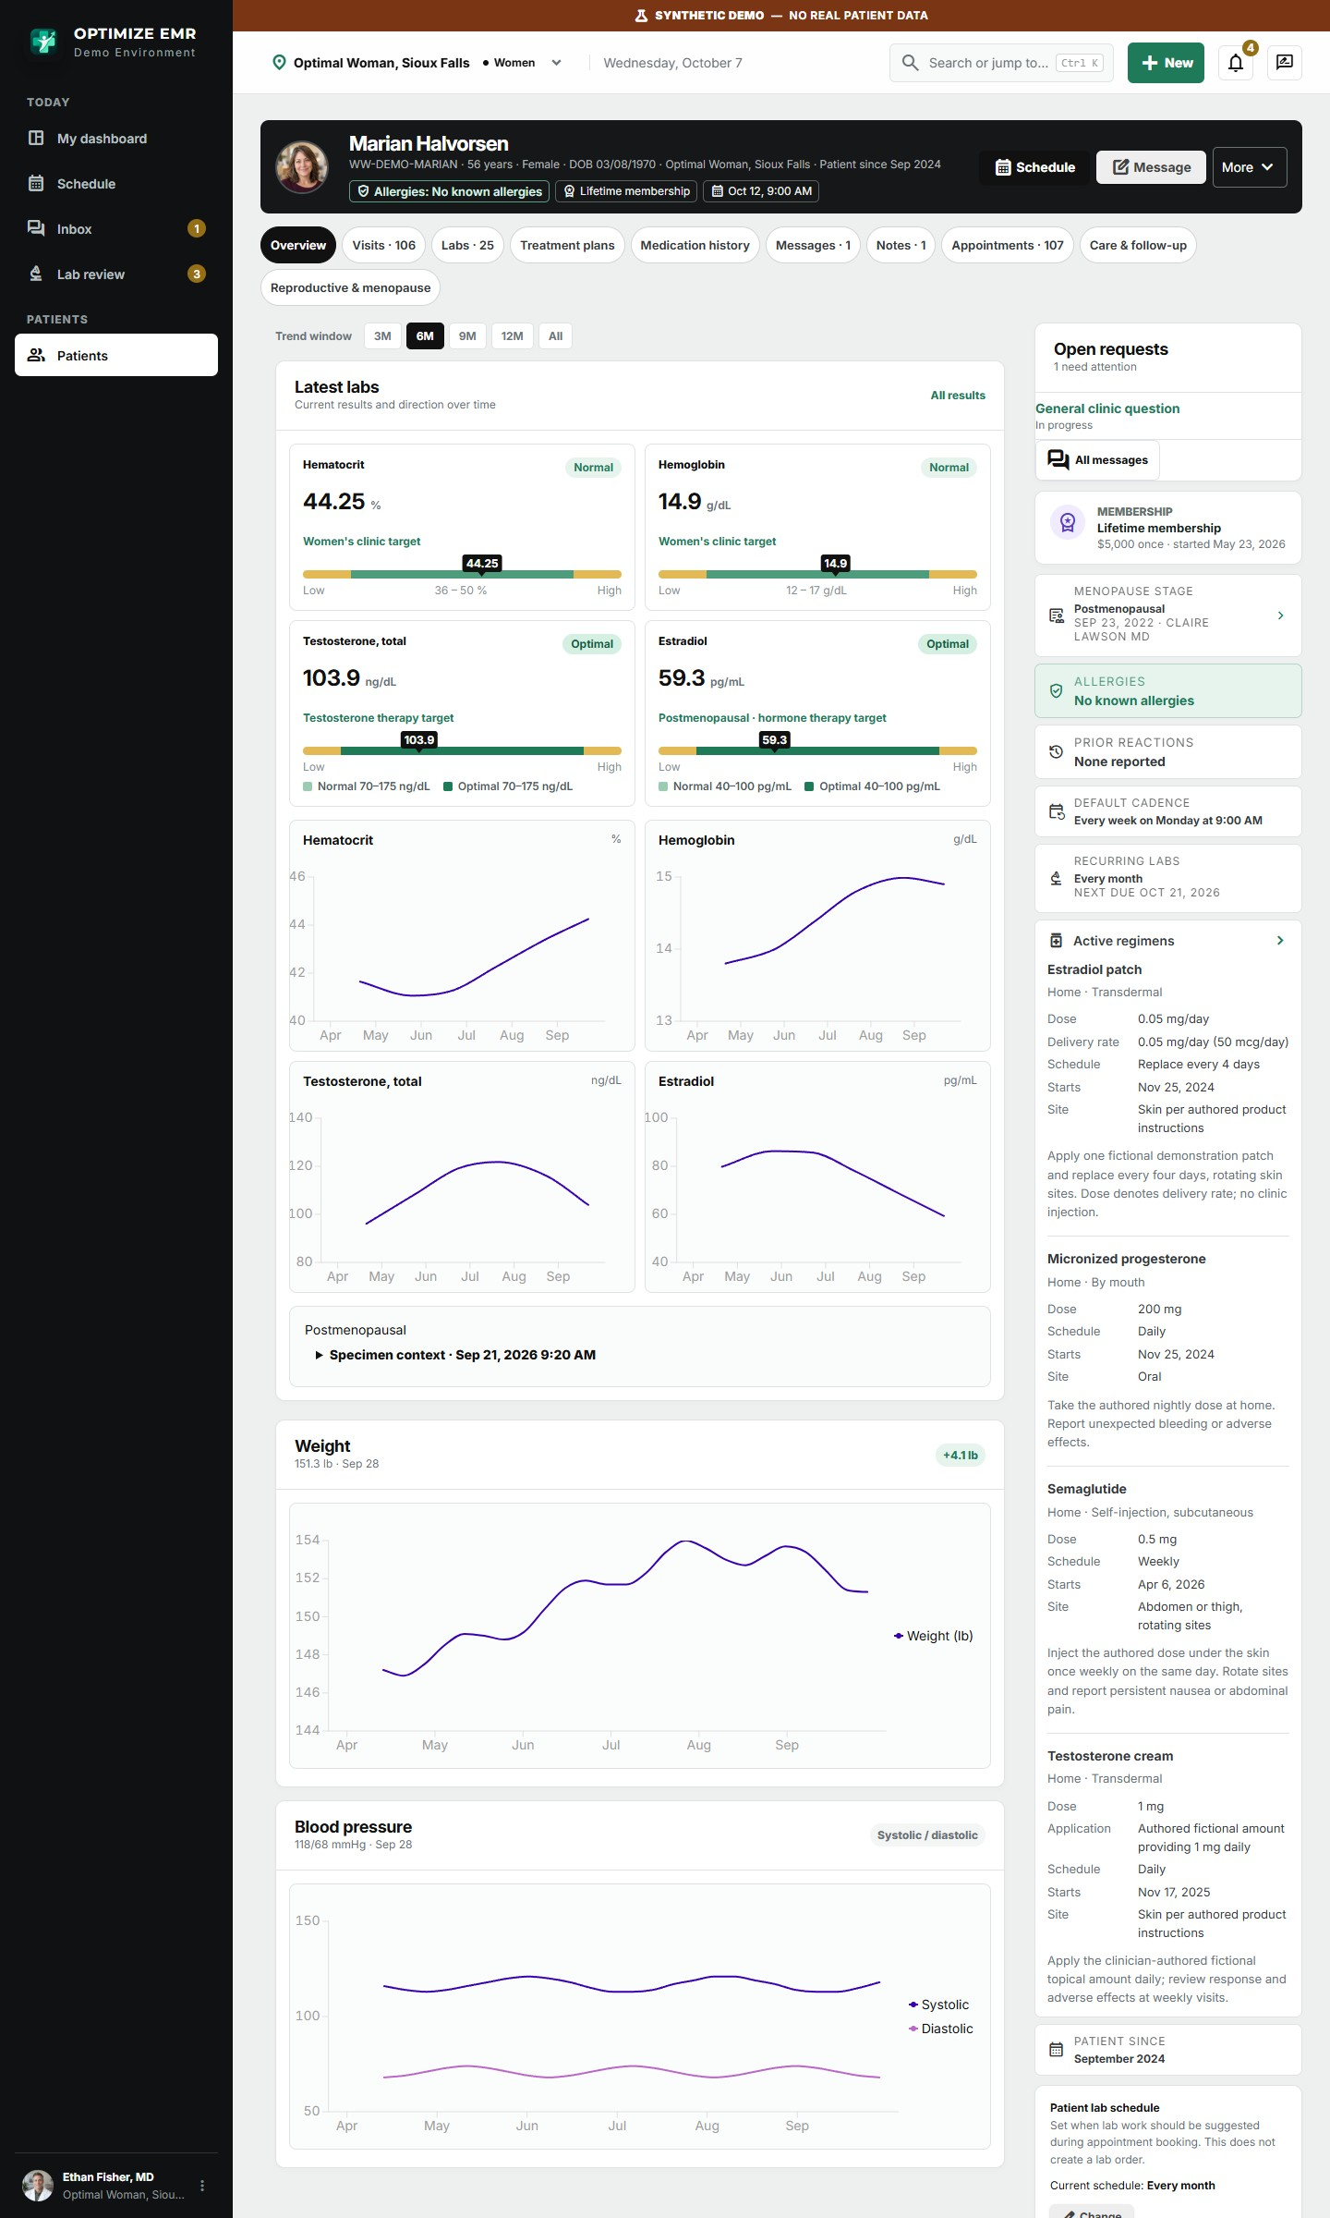
Women's chart overview: results against her optimal ranges, hormone trends, and her active regimens alongside.
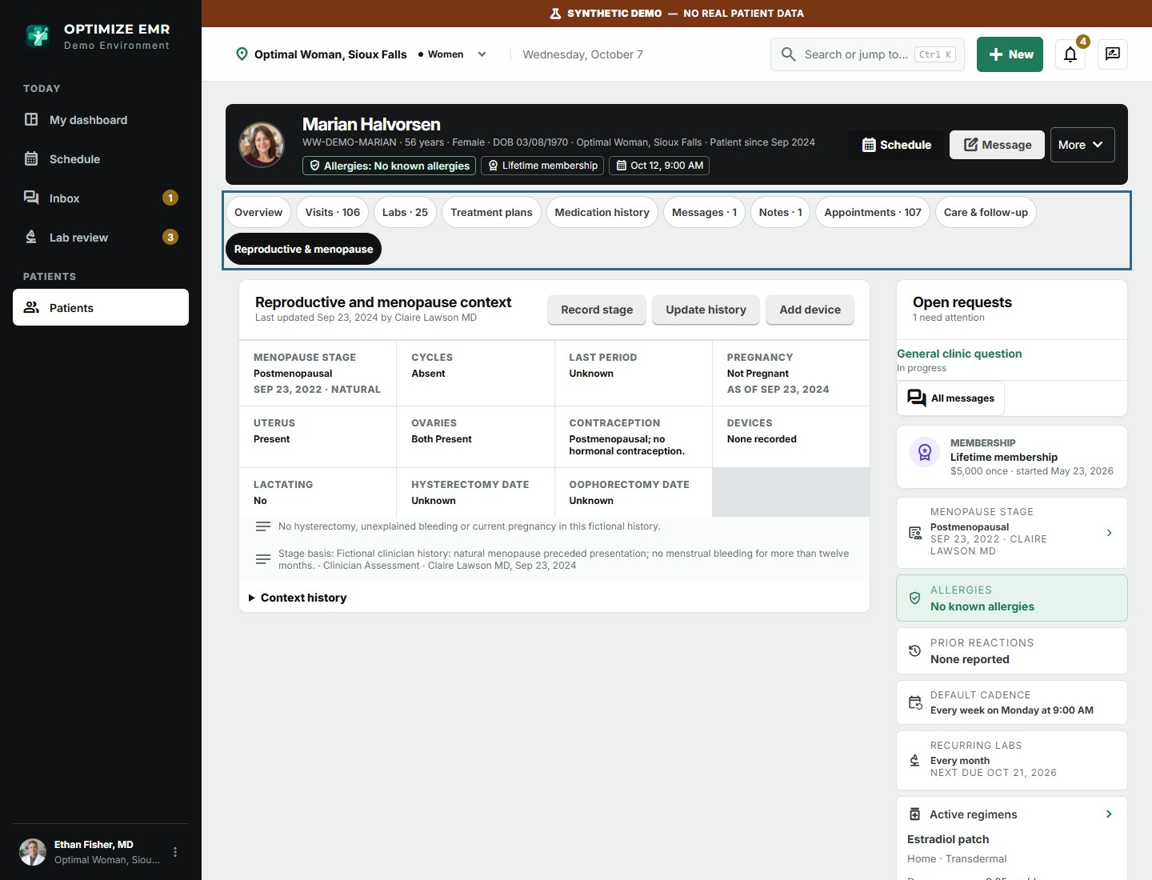
Reproductive and menopause context has its own chart tab, with a dated history of every change.

Treatment plans with a complete history
Providers author each therapy once: medication, dose, frequency, formulation and instructions. Every change is kept as a dated version with its reason, so the full titration history is always available, and the current plan drives the visit workspace and the patient portal automatically.
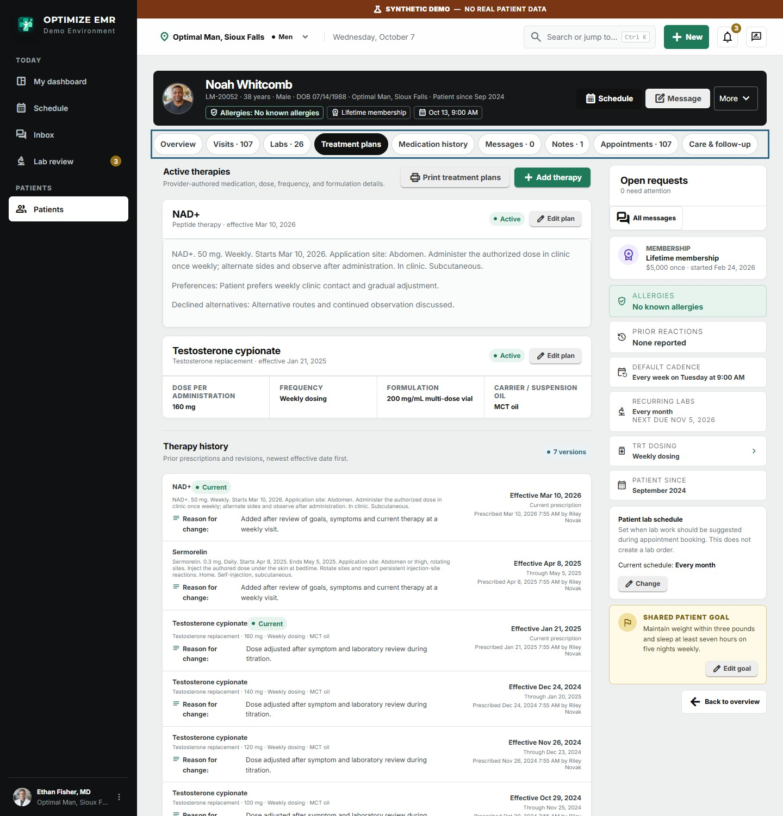
Testosterone and a weekly NAD+ injection as active therapies, with the dated history of every prior plan version.

Peptide and wellness therapy in the same plan
Peptide therapies such as sermorelin, NAD+ and semaglutide are catalog items like any other. A provider adds one to the plan as a clinic-administered injection or a home regimen, and from then on it appears in the visit, the medication history, the patient portal and the business reports alongside hormone therapy.
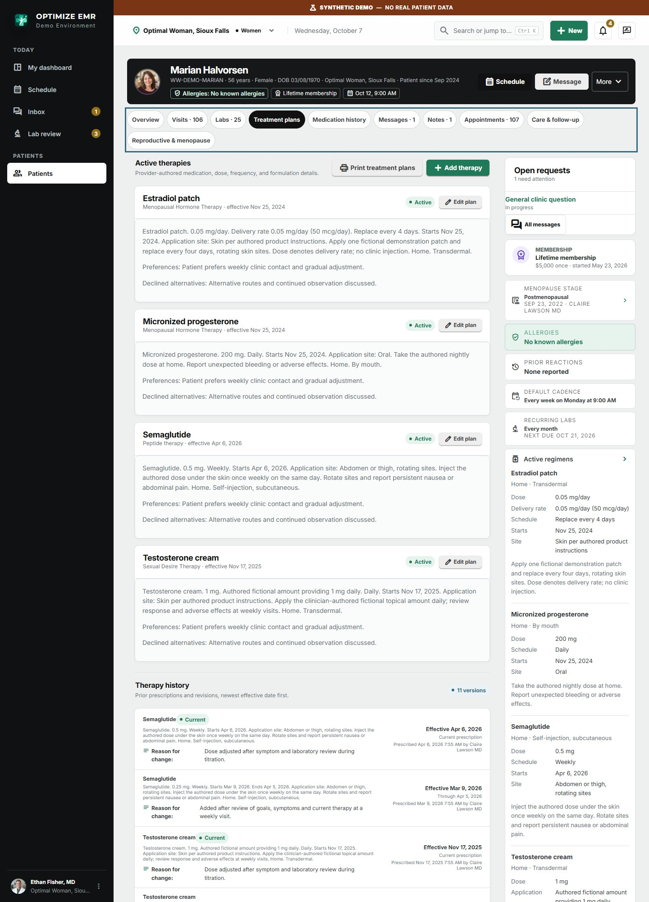
A women's plan combining an estradiol patch, oral progesterone, testosterone cream and weekly semaglutide, each with its own dose and instructions.
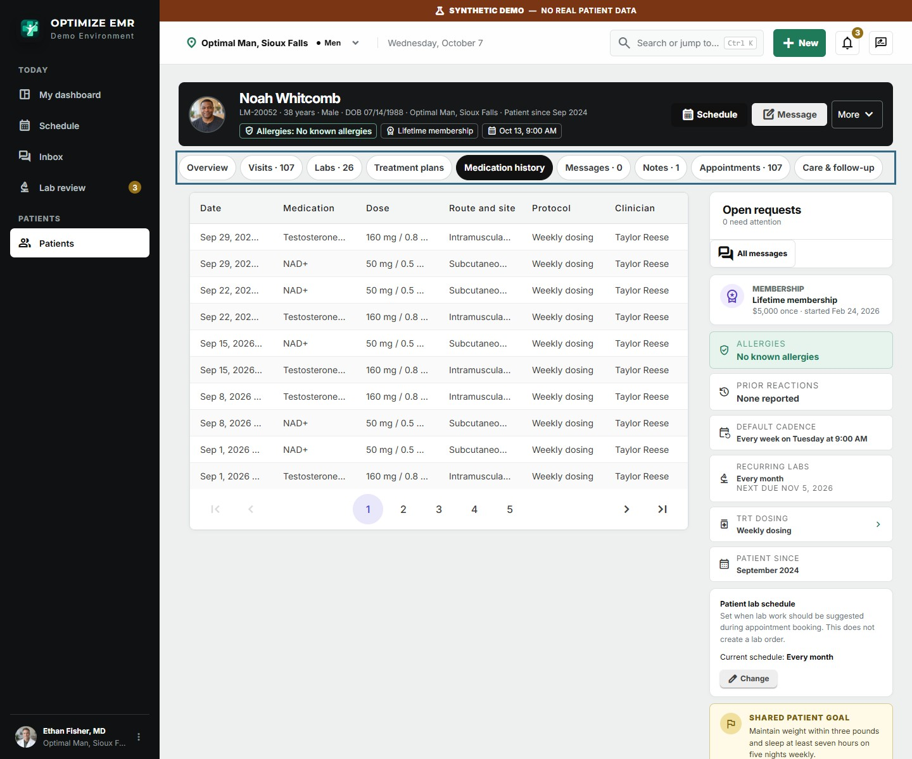
Medication history: every clinic administration with dose, route, site and lot.
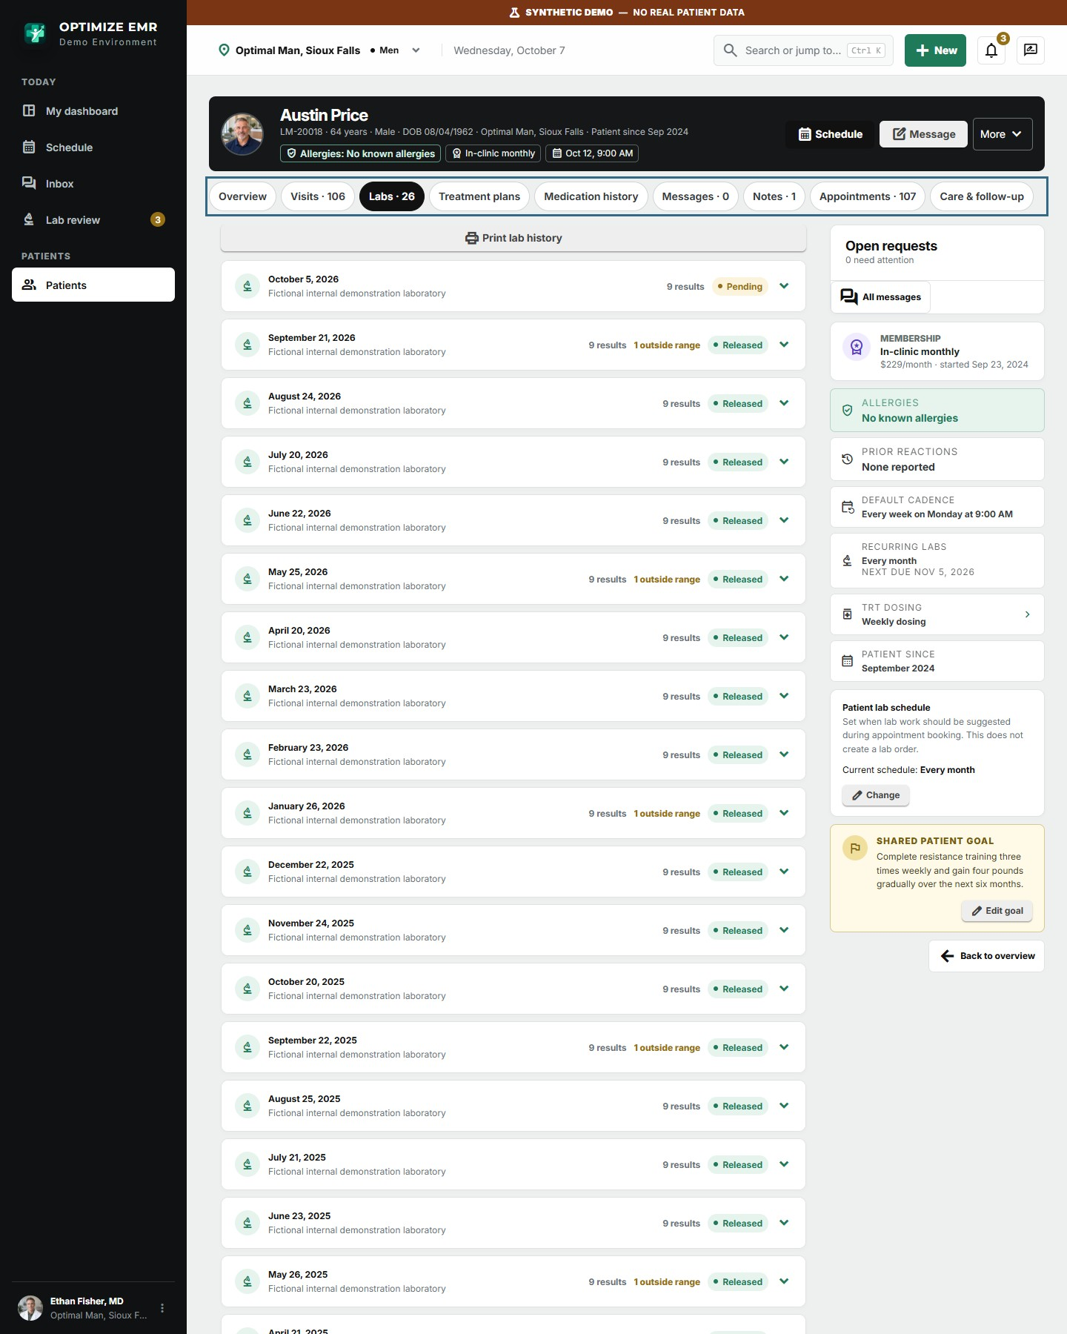
Every lab panel in the chart, with outside-range counts and release status.

Communications that never fall through the cracks
Patient requests arrive in one shared clinic inbox instead of scattered voicemails and sticky notes. Each request is linked to the chart, routed to the right team, given an owner and a response-due time, and answered securely.
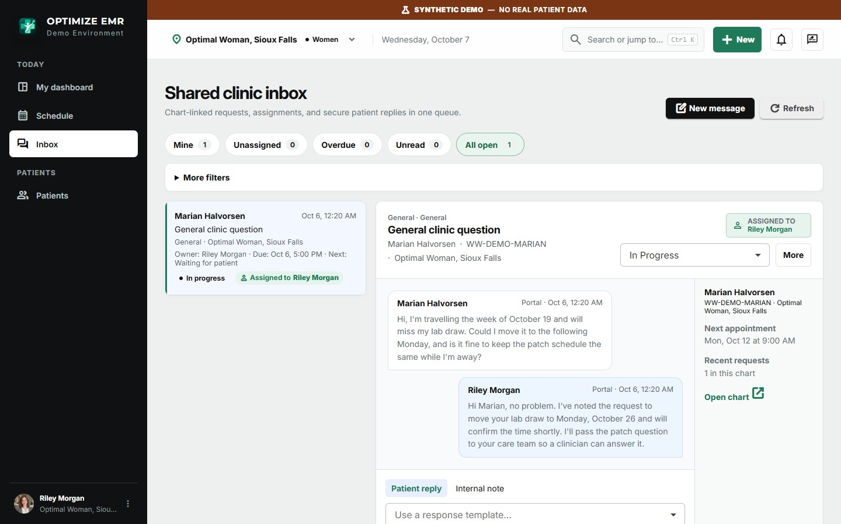
Shared clinic inbox: the request, the owner, the due time, the chart context and the secure reply in one view.
- Routing by request type. Scheduling, clinical questions, refills, lab questions and billing each go to the queue you choose for each clinic.
- Response templates and internal notes. Approved replies keep answers consistent, and staff can add notes the patient never sees.
- Automated reminders. Appointment, lab-release and follow-up notices go out by portal, text or email according to each patient's own preferences.
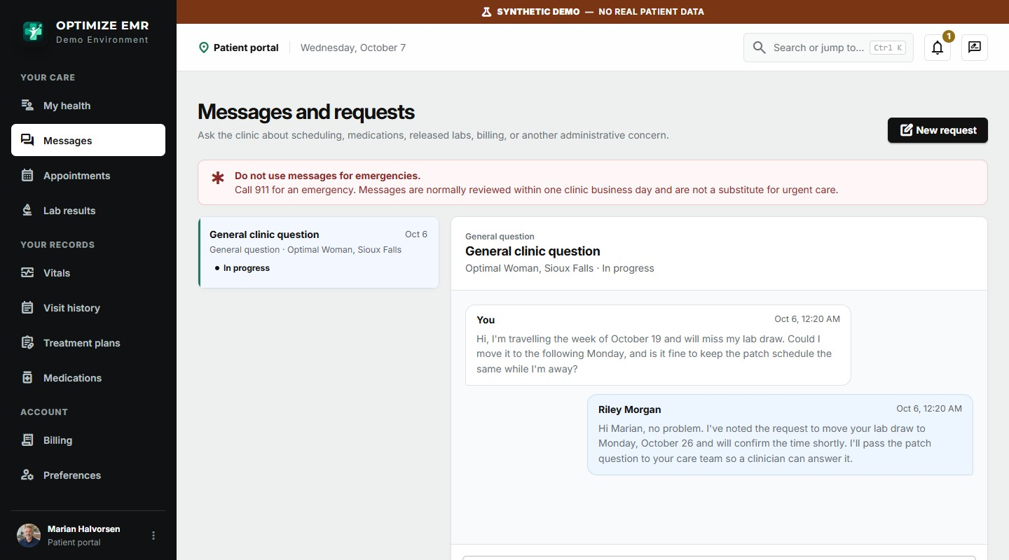
The same conversation as the patient sees it in the portal.
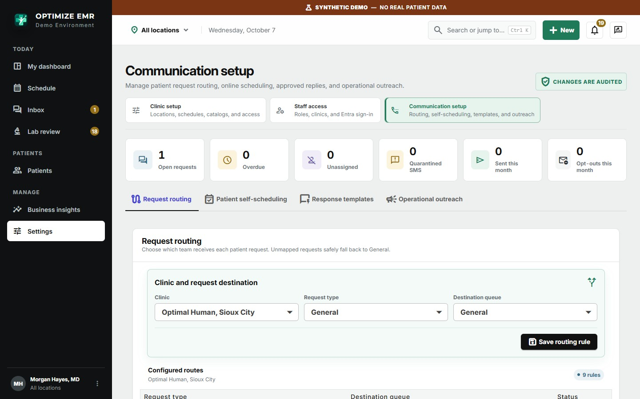
Communication setup: request routing, patient self-scheduling, response templates and outreach.

A patient portal your patients will actually use
Patients who can see their own progress stay engaged and stay on therapy. The portal gives them their results, plan, visits and a direct line to your clinic, in language they understand.
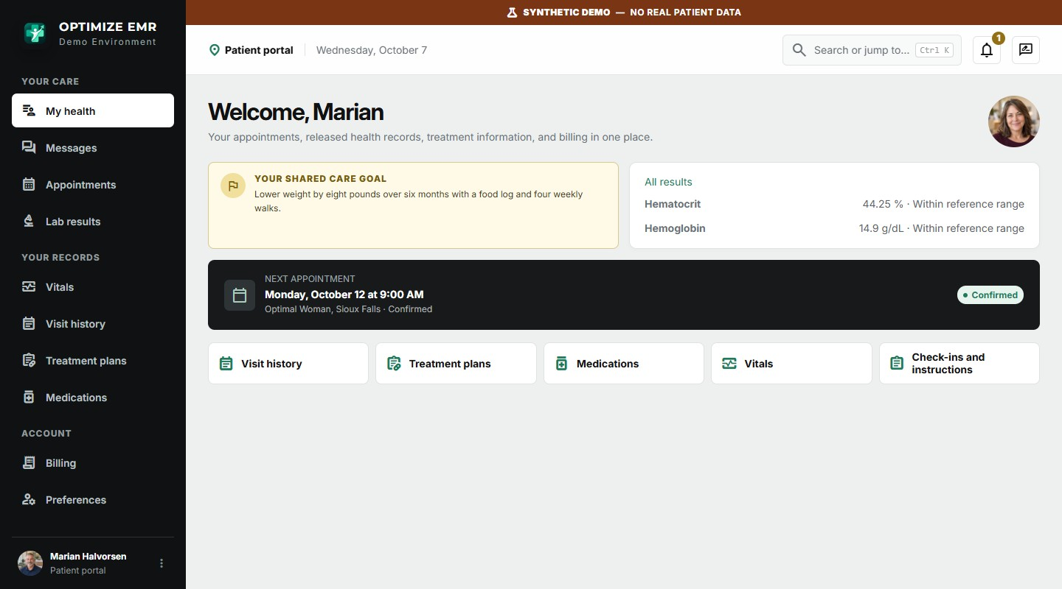
Portal home: the shared care goal, latest results, the next appointment and shortcuts to every record.
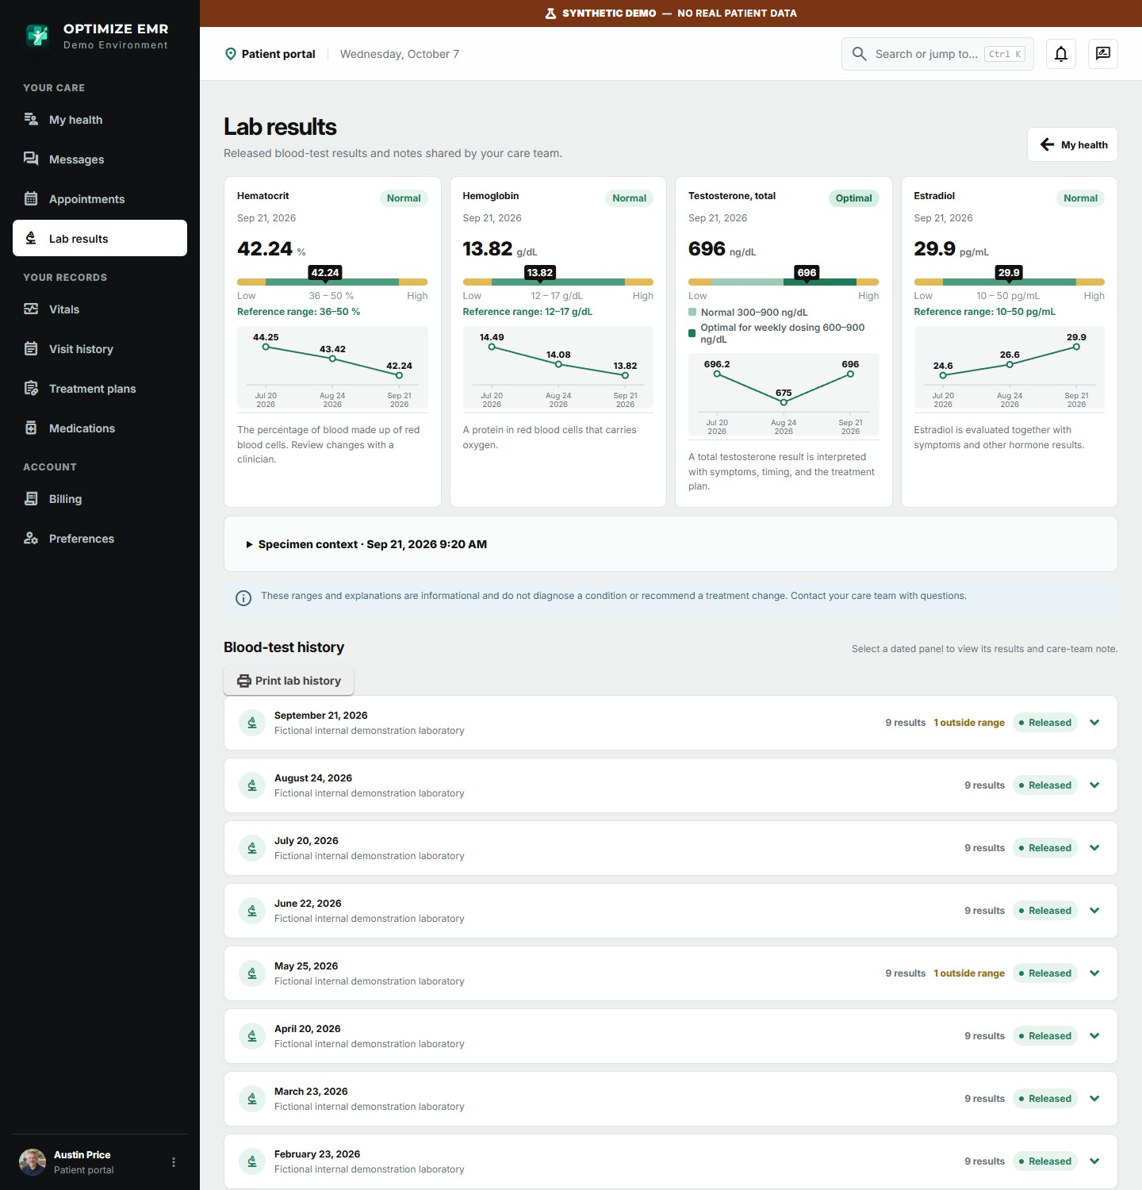
Released lab results with a labelled trend chart and plain-language explanations. The optimal band shows patients what they are working toward.
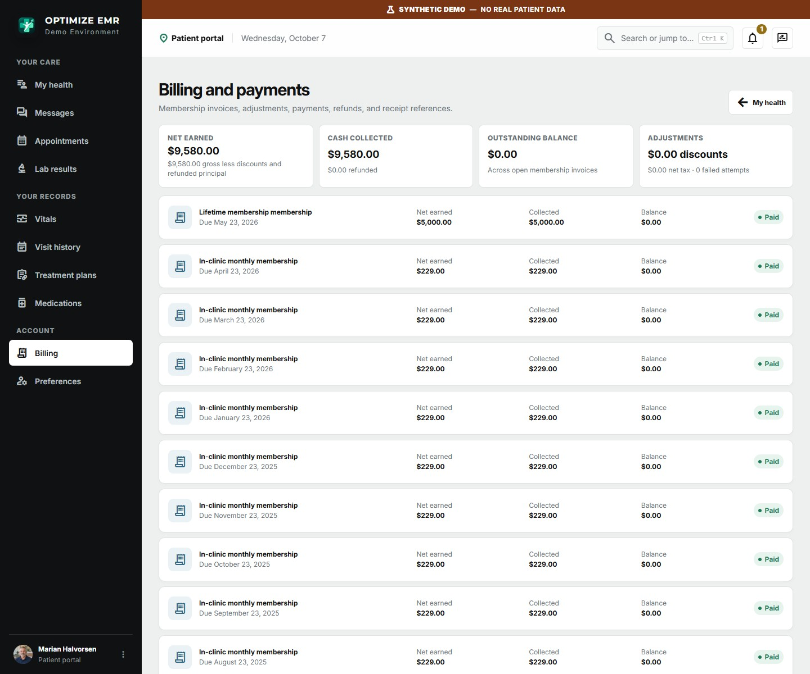
Membership billing: every invoice, payment and balance is visible to the patient.

Designed for the phone in their pocket
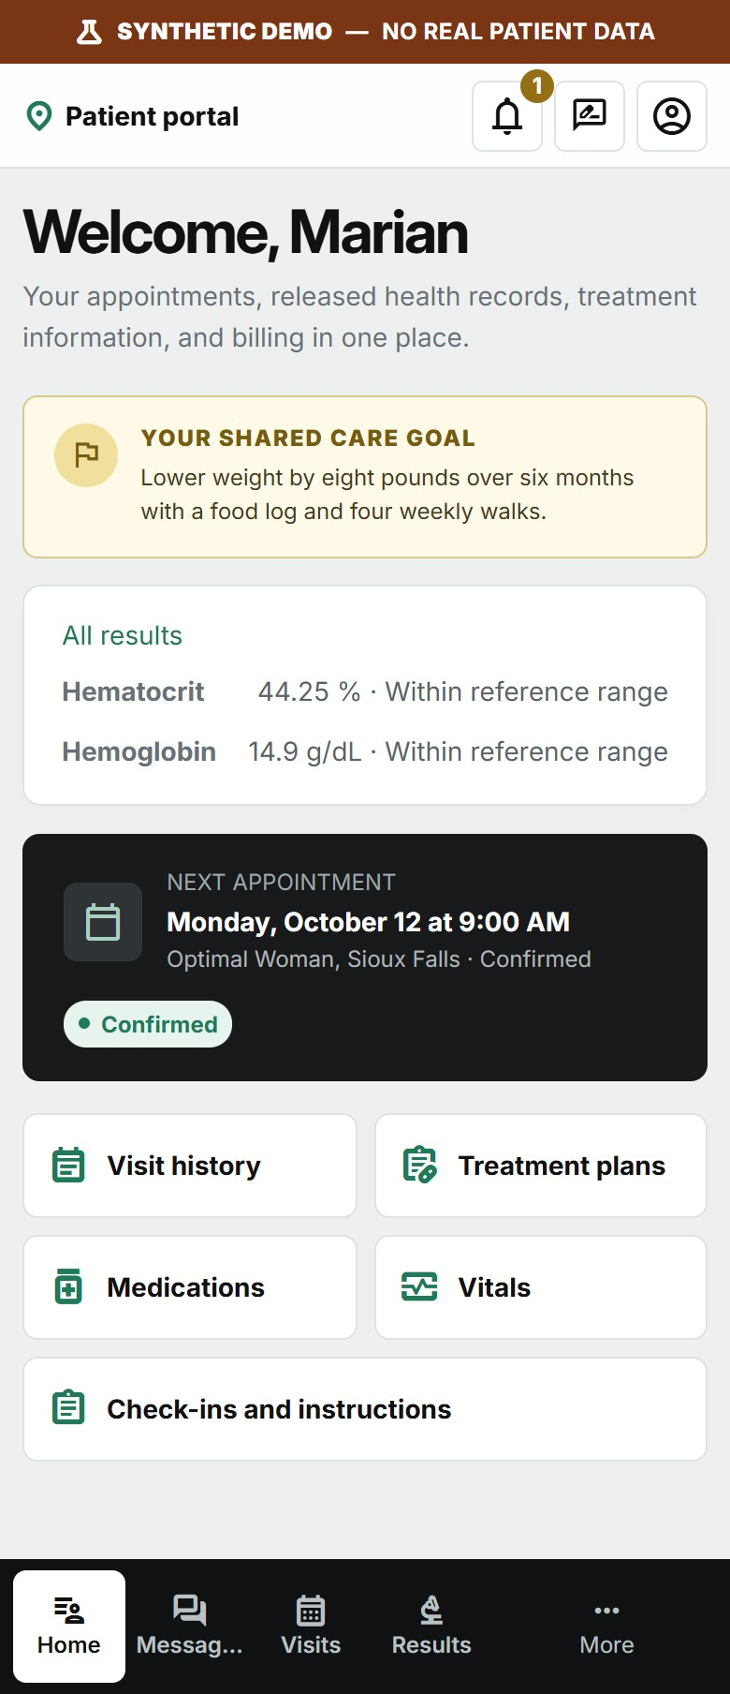 | 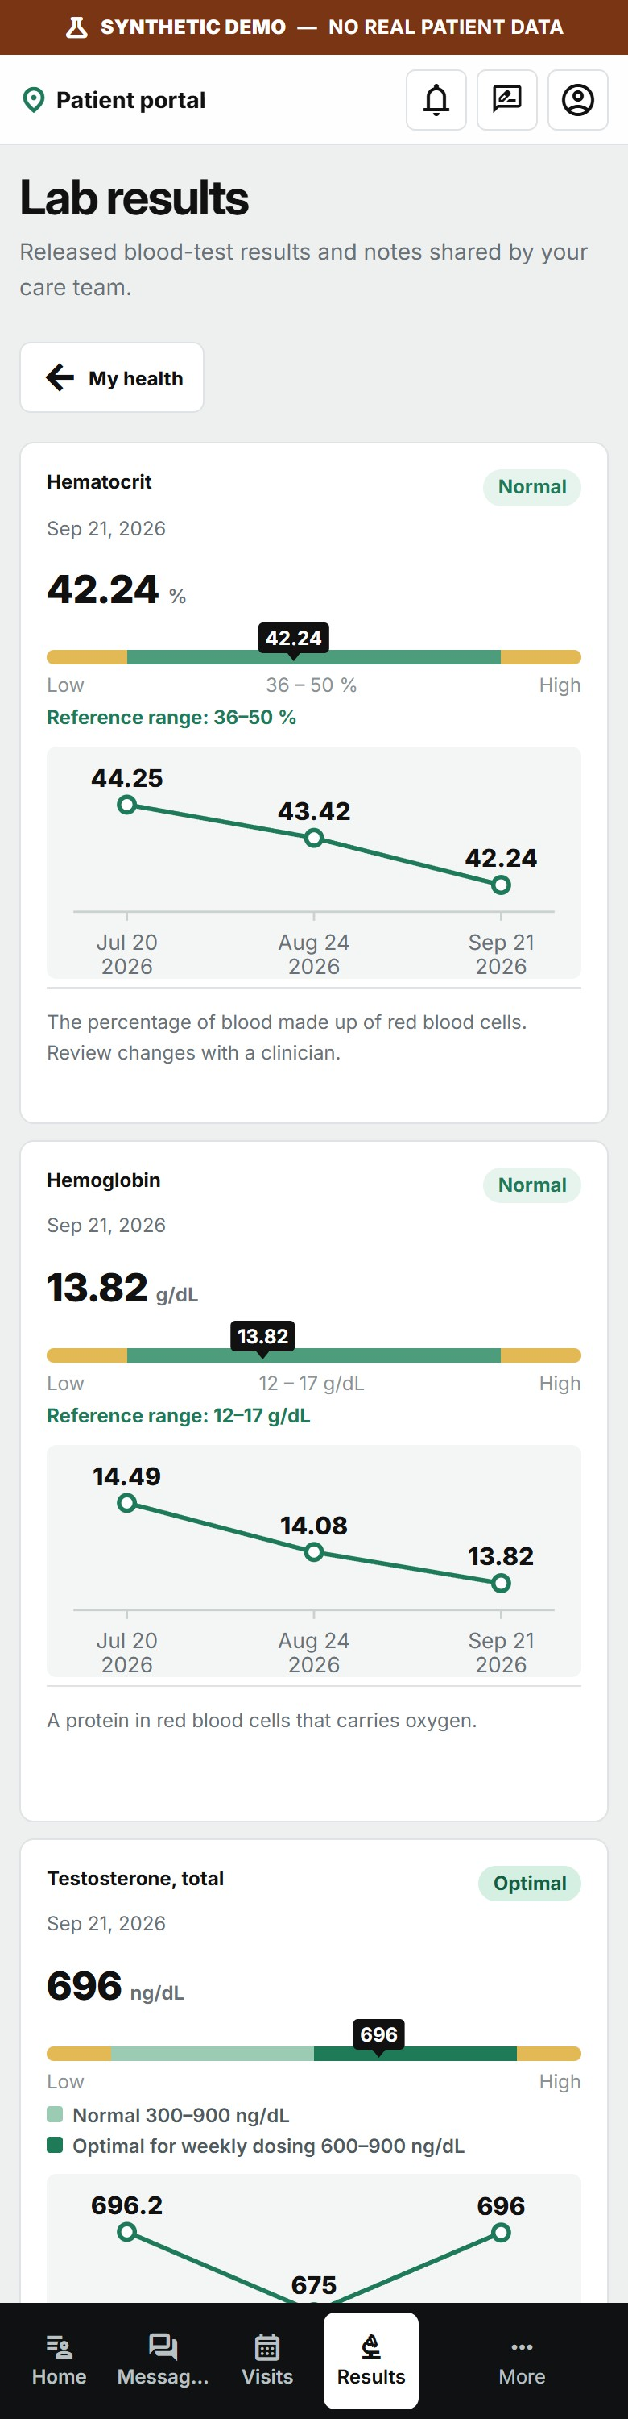
The portal on a phone: home screen and lab results.
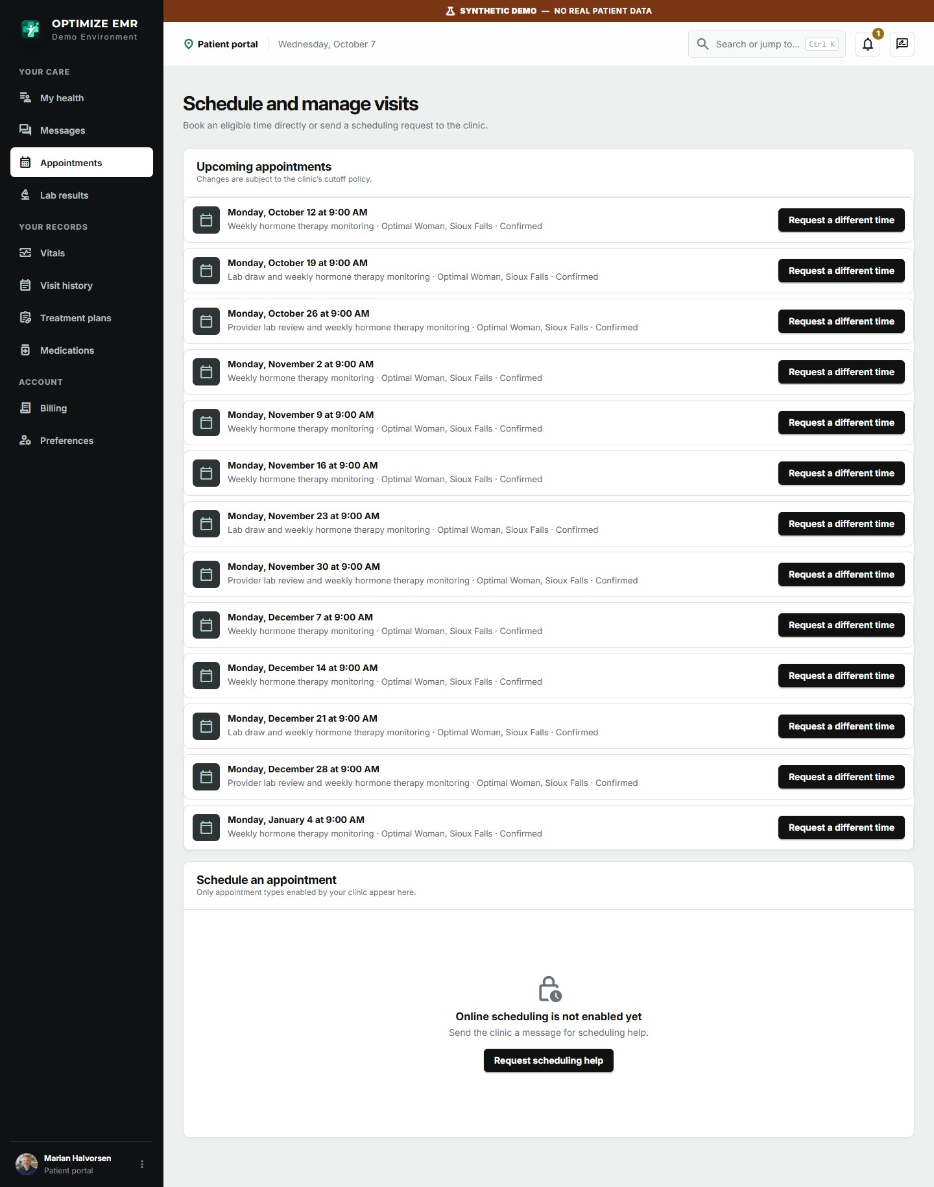
Upcoming visits with the option to request a different time or book an eligible slot.
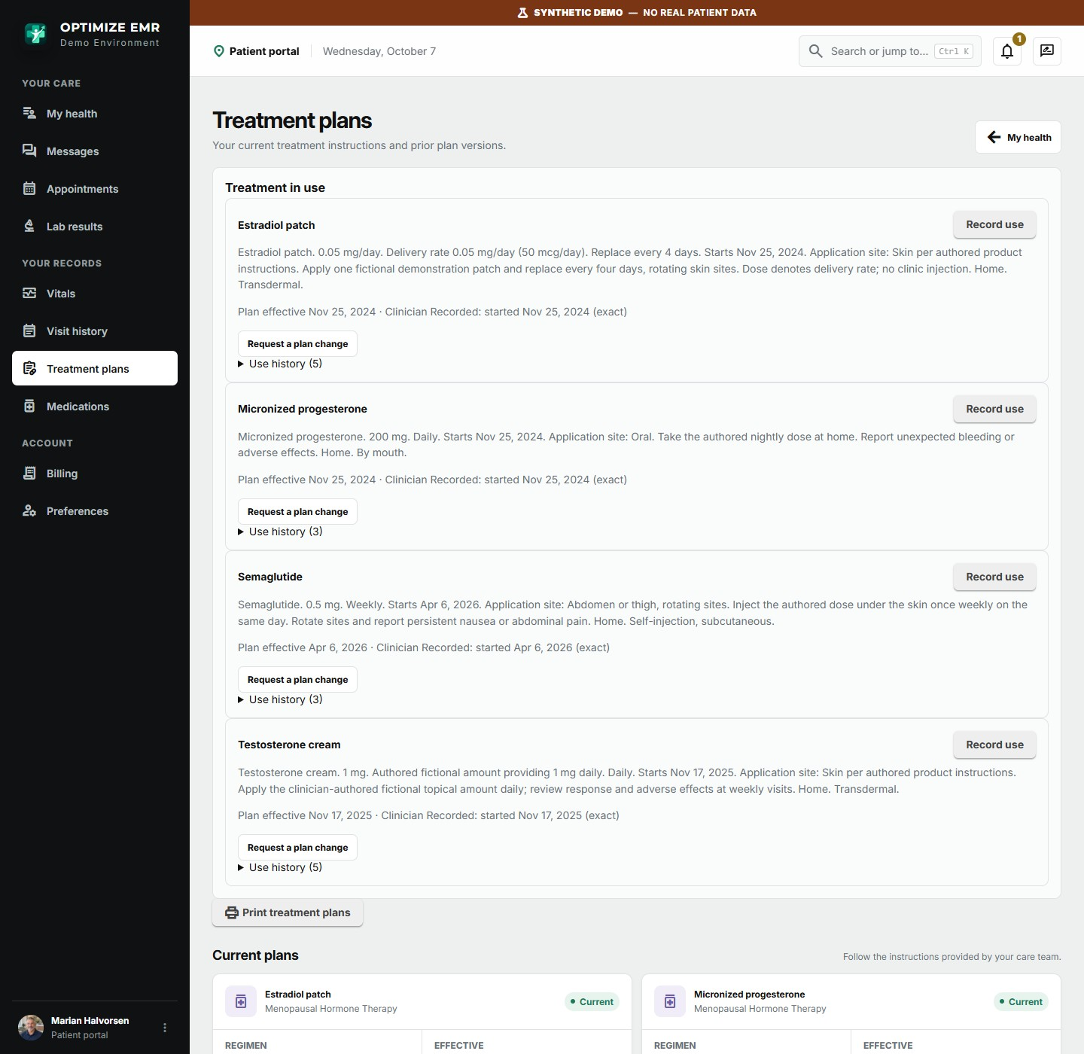
Current treatment instructions. Patients on home therapy can record each use and request a plan change.

Business insights: run the clinic on numbers
Owners and directors get a decision workspace across every location: growth, staffing coverage, patient demand, therapy mix and membership revenue. Filter by clinic, patient cohort and period, and drill from a chart into the detail behind it.
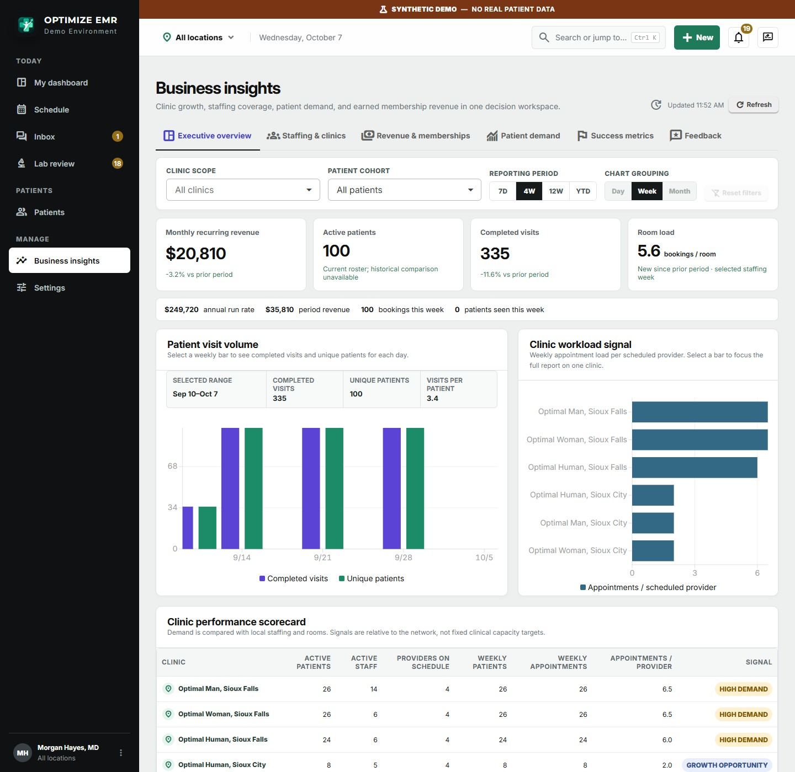
Executive overview: recurring revenue, active patients, completed visits, room load, and a clinic-by-clinic performance scorecard.
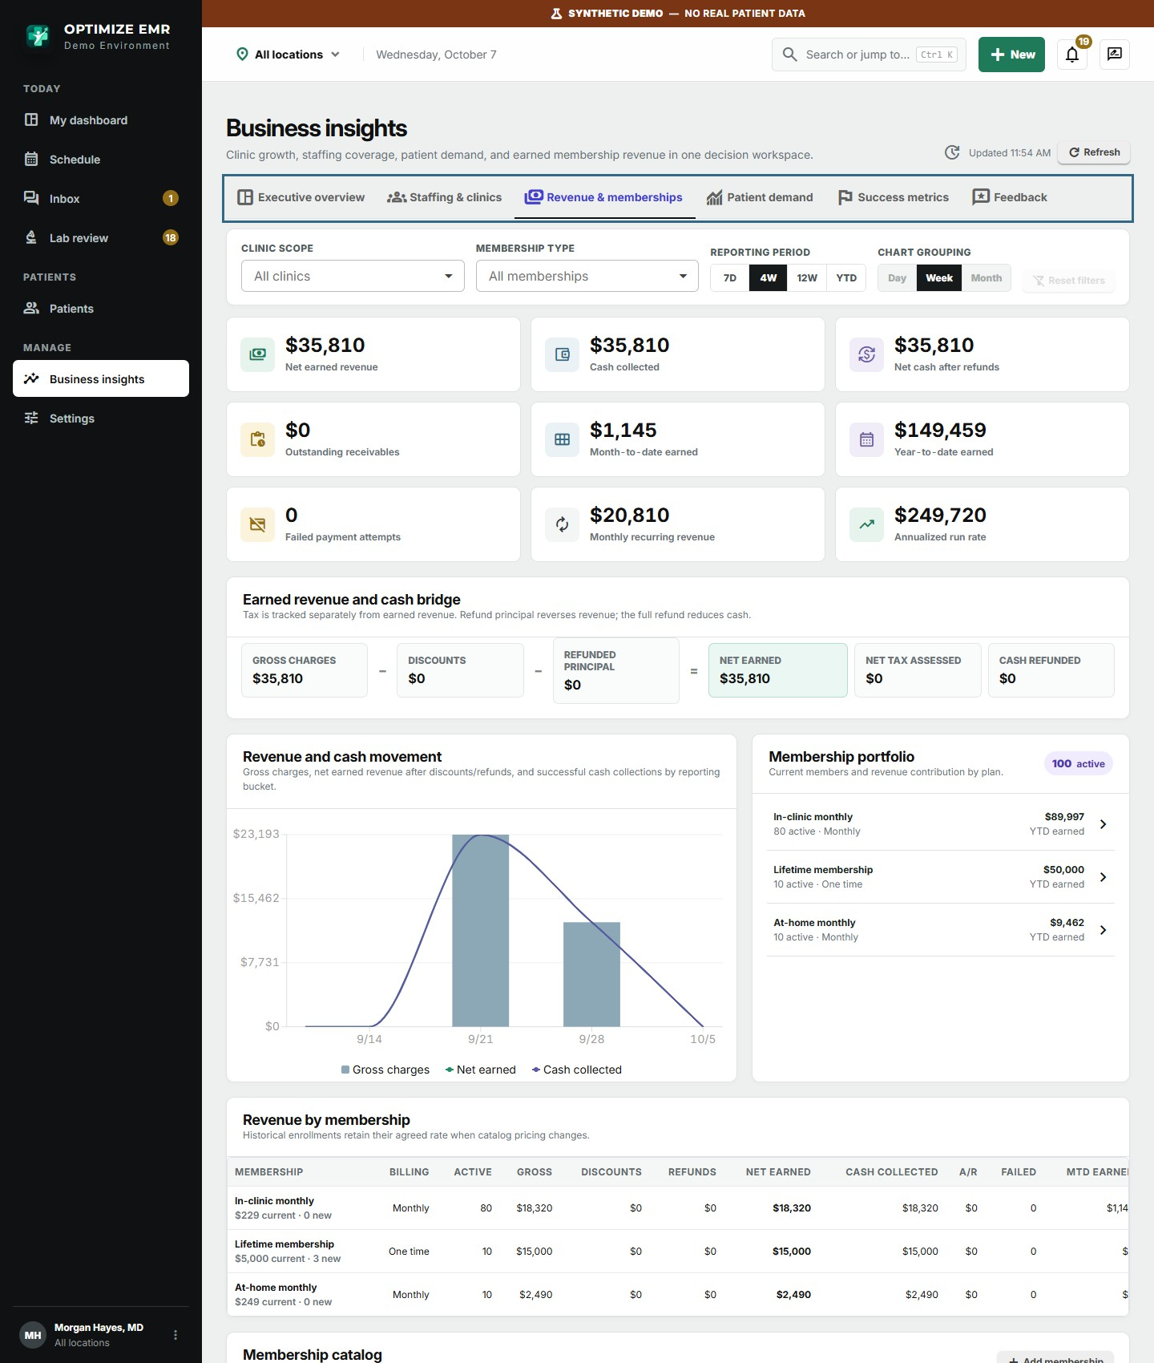
Revenue and memberships: earned revenue, cash collected, the membership portfolio and revenue by plan.
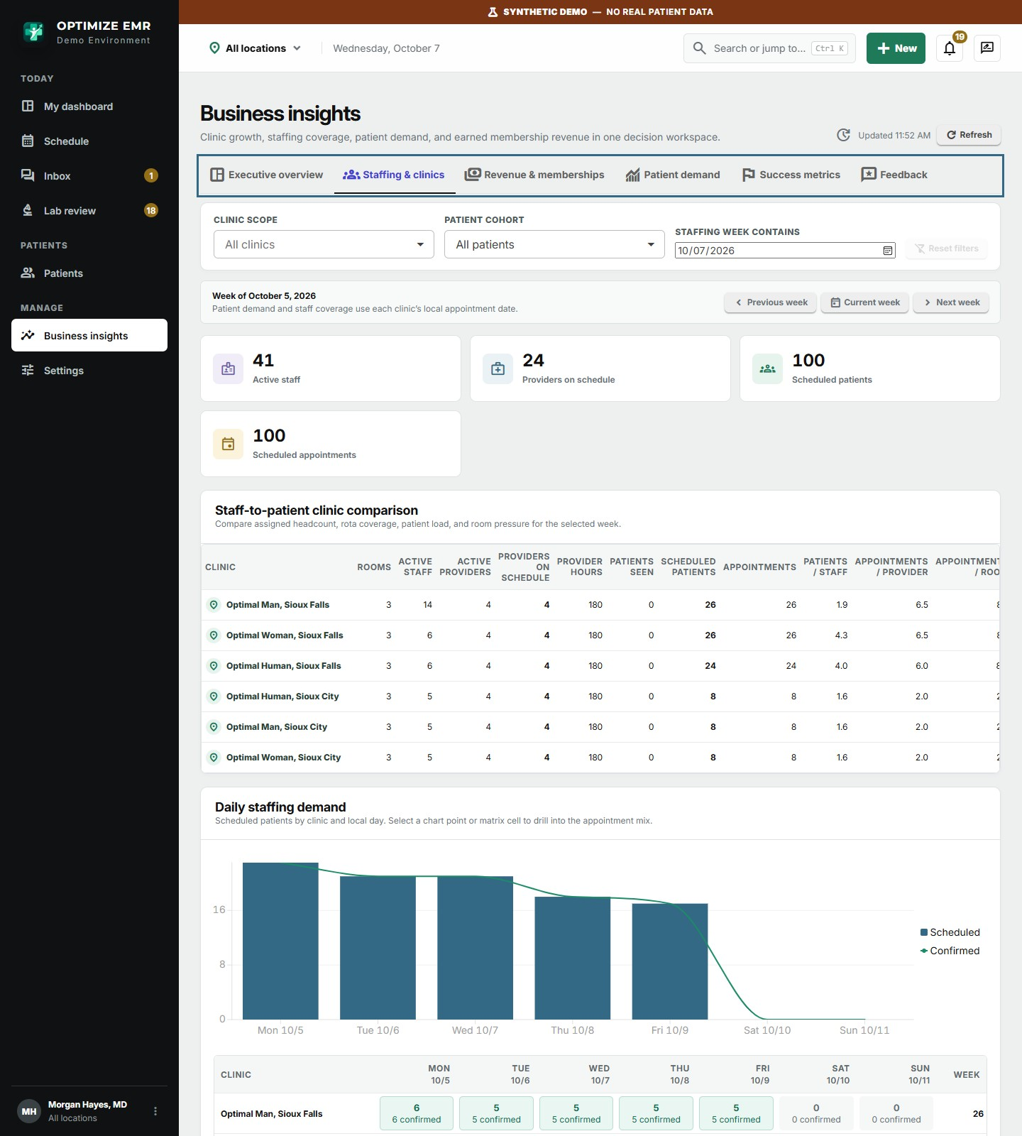
Staffing and clinics: staff-to-patient comparison and daily staffing demand, to match coverage to bookings.
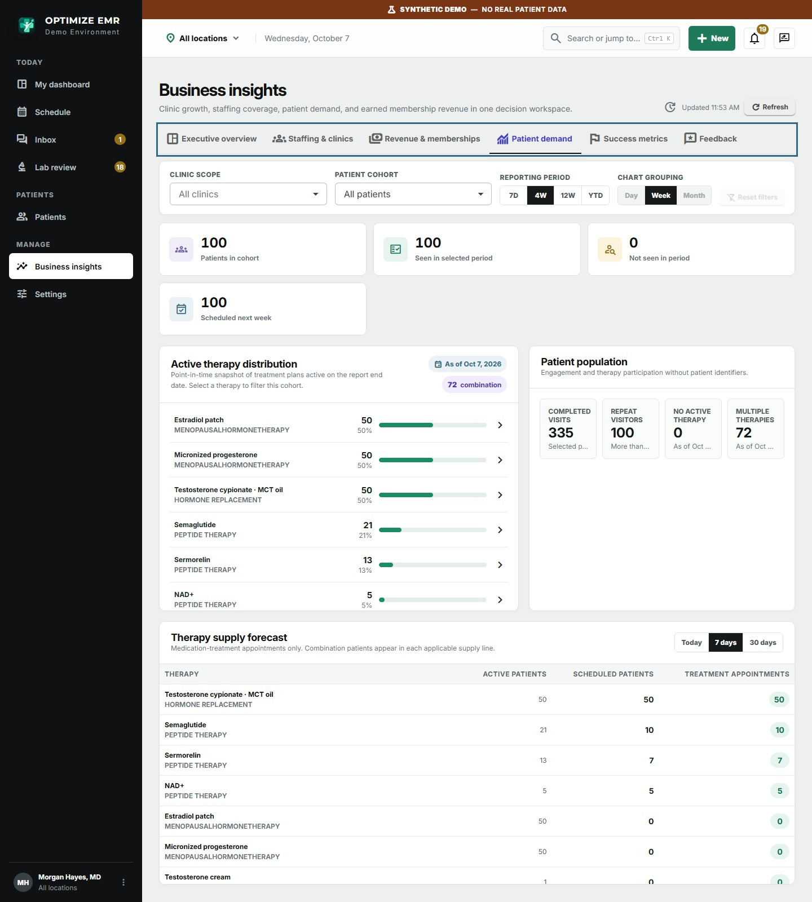
Patient demand: therapy distribution across the patient base and a supply forecast for upcoming treatments.
- Use resources better. See which clinics are over- or under-staffed for their bookings and where rooms sit empty.
- Grow deliberately. Track new and retained patients, visits per patient, and which therapies and membership plans drive revenue: monthly in-clinic and at-home memberships and one-time lifetime memberships are reported side by side.
- Plan supply. Know how much of each therapy the coming week and month will need.
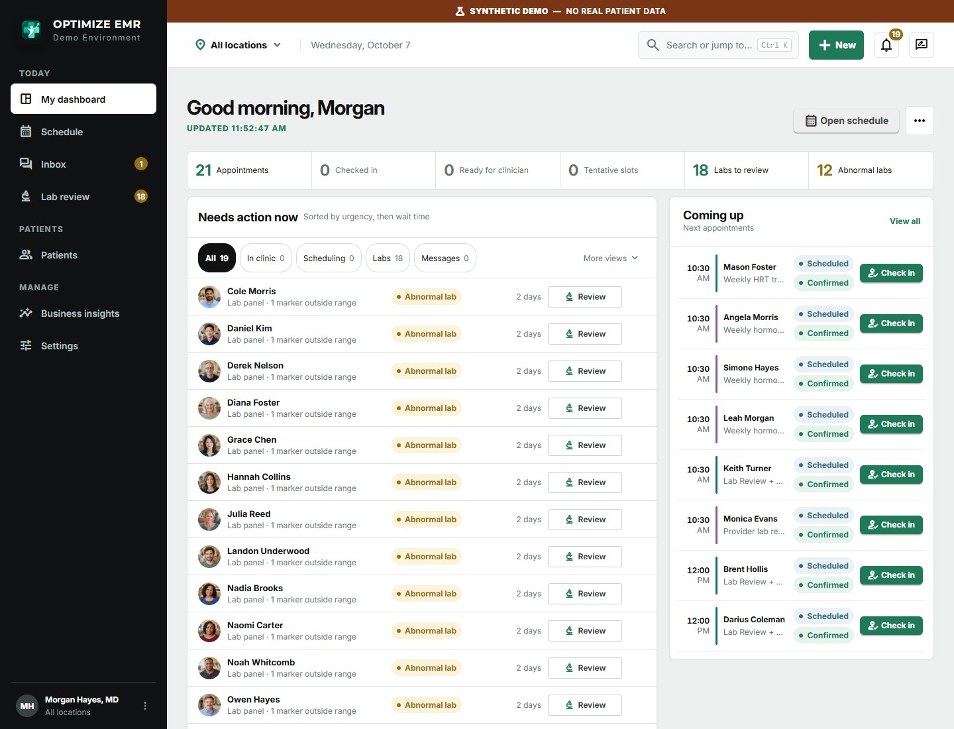
The owner's dashboard brings work from every location into one prioritized list.

Set up your way: configuration and customization
Clinic setup lives in one searchable Settings area, and every change is audited. Most of what makes your clinic different is configuration, not custom code.
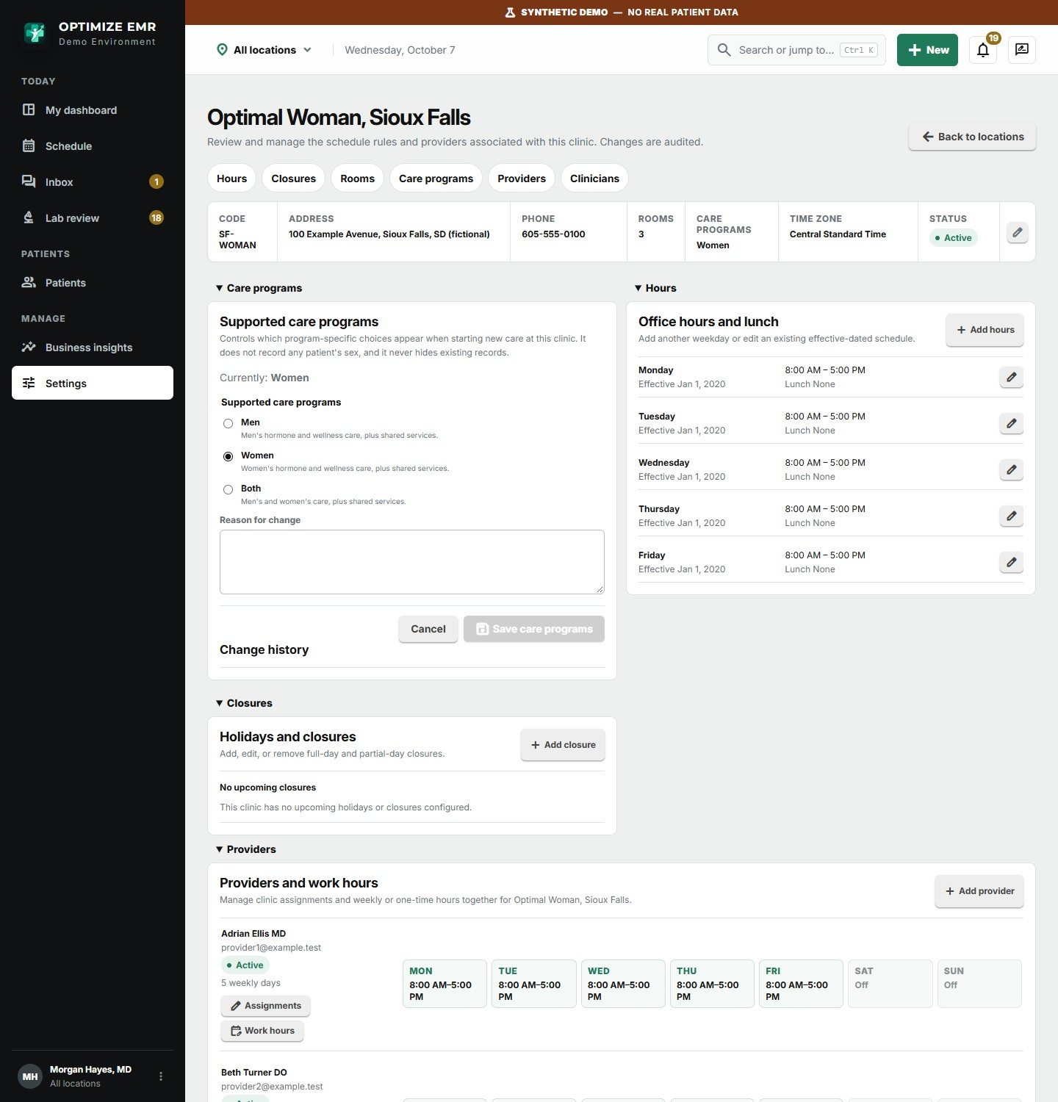
Each location has its own care programs, hours, closures, rooms, providers and clinician work hours.
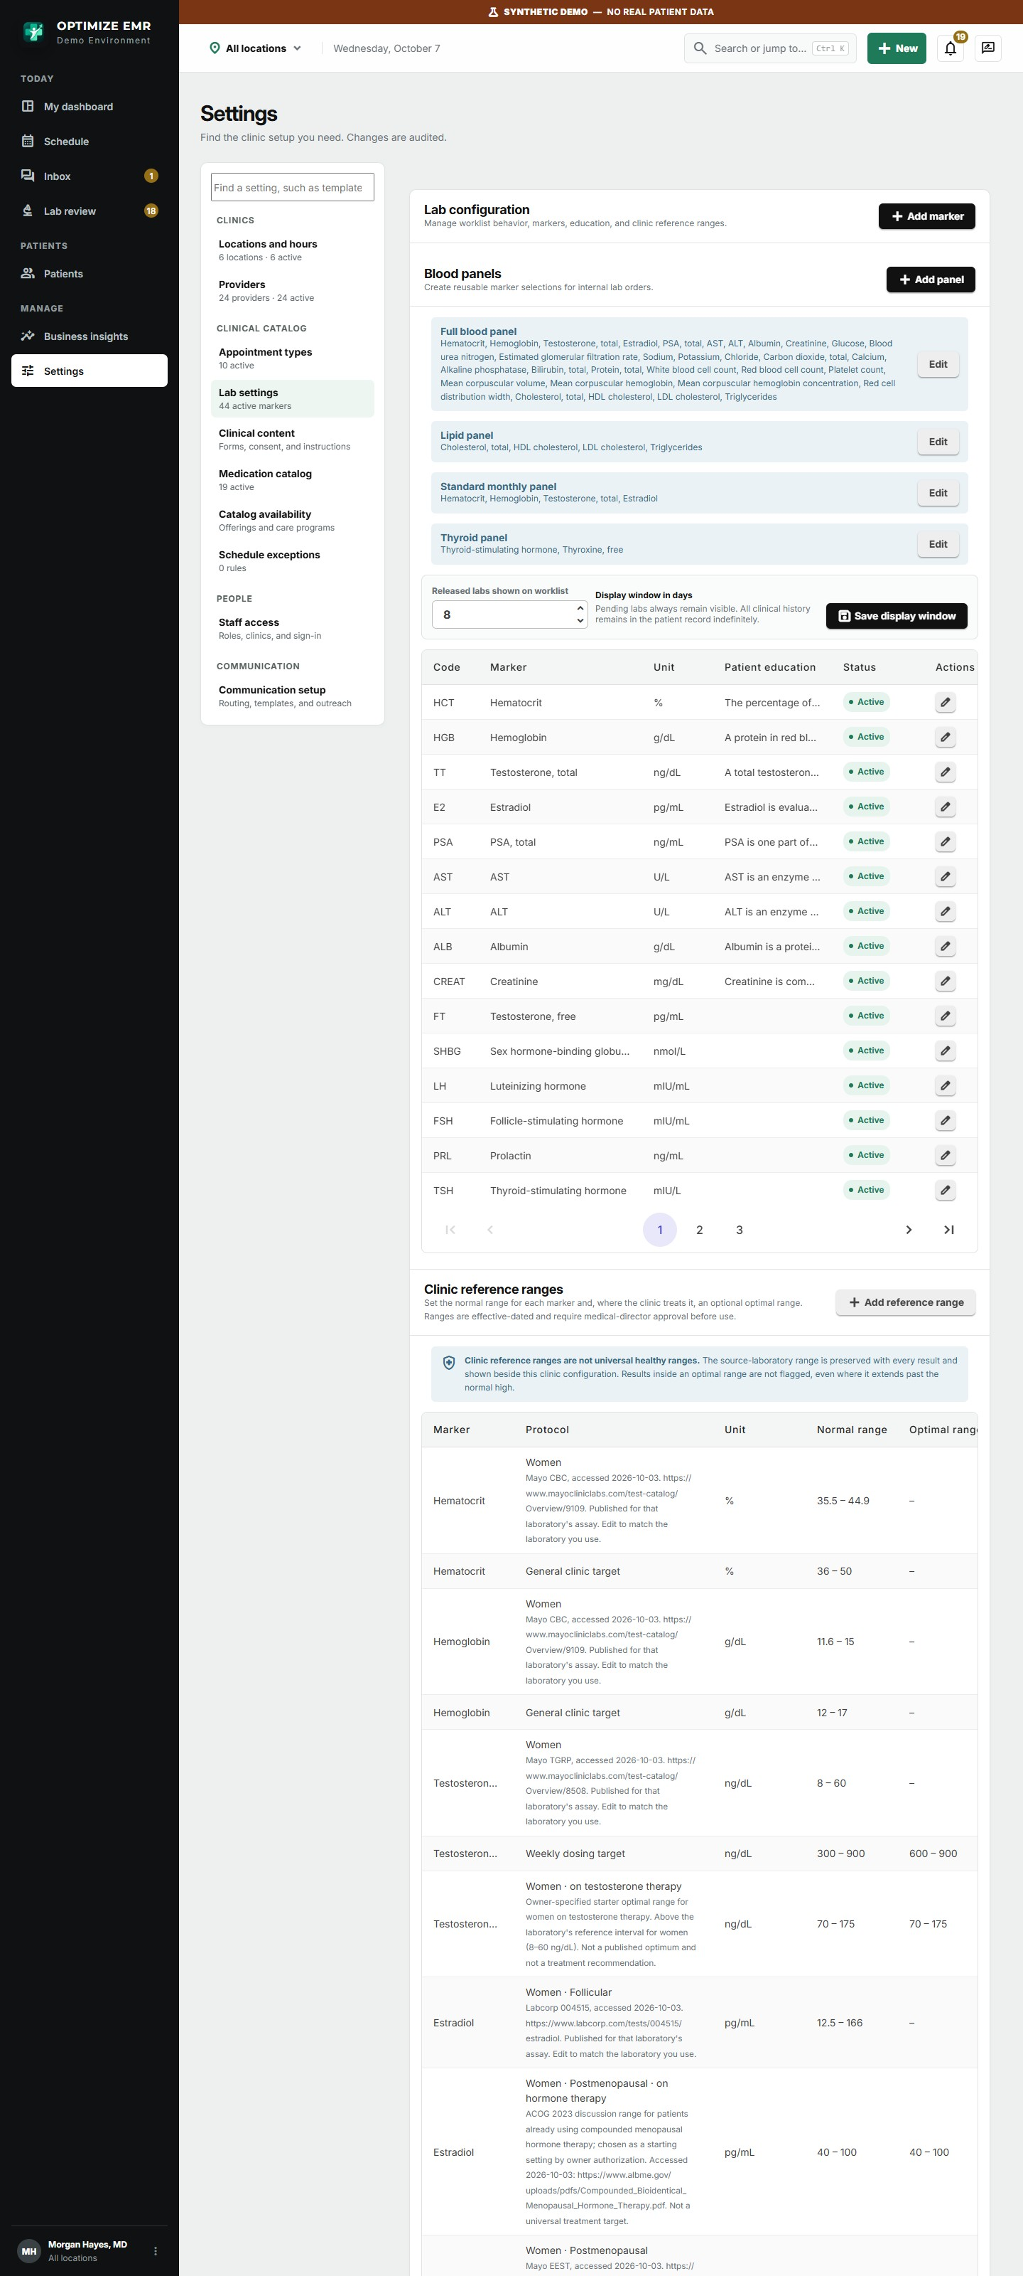
Lab configuration: blood panels, markers with patient-facing education, and the clinic's normal and optimal ranges for men and women.
- Appointment types with their own duration, resources and workflow steps.
- Medication and therapy catalog covering testosterone, menopausal hormone therapy, sexual wellness and peptide therapy, with per-clinic availability.
- Clinical content such as intake forms, consents and patient instructions, versioned so every signed copy keeps its original wording.
- Role-based access. Front desk, clinical assistants, providers, location and organization administrators, business directors and owners each see only the screens and locations their role needs. Staff sign in with their Microsoft work account.
- Accountability built in. Clinical and configuration changes are recorded with who made them and when.

Customizations are available
Every optimization clinic has its own protocols, visit types and reporting needs. If something you rely on is not shown here, ask. Optimize EMR is actively developed for this specialty and can be tailored to your clinic.
Contact sales@codeforgedsystems.com to discuss what you need.

Next steps
The best way to judge an EMR is to run your own day through it.
- Request demo access. Email sales@codeforgedsystems.com and we will set you up on the demonstration system with sample men's, women's and combined clinics.
- Walk a real day. Check in a patient, complete a weekly treatment visit, review and release a lab panel, and answer a portal message, as each member of your team.
- Tell us what is different about your clinic. We will show you how to configure it, and where a customization would serve you better.
- Plan your rollout. Start with one location or bring every clinic on together.
Contact
Email: sales@codeforgedsystems.com
Arrange access to the demo system, or discuss your EMR needs. Customizations are available.

About this document. Screens were captured from the Optimize EMR demonstration environment and show fictional patients, staff and clinics. Features and layouts may change as the product develops. Each clinic remains responsible for its own regulatory obligations; talk to us about the agreements, deployment and operational controls your practice requires.

